The emotional perfection of Jesus.
© By Gerard Feller
In the Lord Jesus there was no sin; His body was in a completely open, perfect and balanced relationship with His soul and spirit. After all, as man He also had felt both physical and psychological pains. John calls the acts of Jesus signs, which were to be symbols of His spiritual life (Jn 2:11; 20:30).
These signs were not sorceries, but were always at the service of spiritual, moral purposes, and of His love.
This serving love directed His acts. Take for example the touching of the sick.
In those days a deaf-mute was more an object of dismay than of pity.
Jesus approached people with a loving heart and a gentle touch (Mark 7:33). Jesus’ meaningful touching of the sick and especially the blind and mute, was loving.
How much of the loving warmth must His hand have radiated to the dead daughter that was laying on the bed? (Mark 5:41). In those days touching a dead body was labeled as unclean. In that way Jesus’ love also won.

Again and again people have formed thoughts about the stature of Jesus. In Psa. 45:2 it is said: “You are fairer than the sons of men”. In Isa.53:2 it is said in another age, that He has no stately form of majesty.
His body language was not manufactured, but perfectly in accordance with His sinless soul.
When they took Him in captivity, the judicial workers drew back for His “body language” of word, view and stature (Jn. 18:6). He tested the numb conscience of the Scribes and Pharisees by catching their eyes at the healing of the man with the withered hand (Luke 6:10).
How furious He was then, but His fury in its turn, made room for a deep sorrow (Mark 3:5). In Mark 10:23 His eyes were also cooperating when He reminded the apostles of the dangers of great wealth. Afterwards in verse 27 he looked at them again and comforted them by ensuring them that with God nothing is impossible.
Jesus knew the power of His eyes. In the night of the betrayal, Jesus led Peter by His gaze to the redeeming exit of deep contrition (Luke 22:61).
With an open eye He observed the natural phenomena. He saw the sparrows on the roof (Mat. 10:29), the lilies in the field (Mat. 6:28), the tailor who patches garments (Matt. 9:16), the children who sit on the market place and call to one another (Luc.7:32).
Jesus used a perfect metaphor, which was in accordance with Someone who had a perfect body language. He let a disciple of the Pharisees to hand Him a coin (Mat. 22:19), He put a child before the disciples (Mat. 18:2), He pointed with a finger to the lilies of the field and the birds (Mat. 6:26,28) on the fishing net on the bank of the sea (Mat. 13:47) and on the Sower and the land (Mat. 13:3). He taught visual lessons by the means of symbolic acts. The apostles had to learn to be the least, and therefore He took a towel and a basin and washed their feet (Jn. 13:14).
They had to know that He was going to die. He broke the bread, which was a sign of His body, in their sight (Mat. 26:26). They had to know that He had to die for them and therefore He handed them the broken bread, so that they may eat it.
They had to know where He was and therefore He ascended to heaven in their sight (Acts 1:9).
The ‘look’ of Jesus has always been a ‘look’ of compassion, love and mercy. His gentleness and kindness caused that parents brought their children to Him, so that He could touch them (Mat. 18:12).
A sunny cordiality had accompanied Him in all His ways, and although Judas was going to betray Him with a kiss, He blamed Simon the Pharisee for not giving Him a kiss (Luke 7:45).
The old oriental use to connect a salutation with a kiss became a Christian use (Rom. 16:16, 1 Cor. 16:20, 1 Pet. 5:14).
We now know that nonverbal communication and body language are an important component of communication (8o %). If we look at Jesus’ speech in public, we notice that He must have been the best communicator of all ages.
Jesus is the best public speaker ever.
Everybody was amazed by His words. Even the court officials of the Jewish Court were defeated by Him and came back with no success with the words: “Never has a man spoken the way this man speaks” (Jn. 7:46). It occurred regularly that thousands of people gathered around Him and jostled for space around Him (Luke12:1).
In the wilderness thousands of men stayed for days with Him and even forgot about the feeling of hunger and thirst (Mark 8:2). Again and again the people were convinced that the speeches of the Scribes were as nothing compared to those of Jesus (Mat. 7:29).
There were often great multitudes around Him (Mark 3:32 and the next verses) or they gathered at the bank of the river, while Jesus was speaking out of a boat (Mark 4:1). Jesus knew how to adapt to all kinds of listeners and had the wondrous feature of never being too simple or too difficult to anyone. He had all speech techniques in His control: the calm tone to persuade and teach; the soft tone to comfort, the persuasive tone of a gentle person who attracts other people. But He could also quote the Old Testament prophets through the “Woes to the ….”, or get furious and very angry.

Jesus was a master in addressing people. He could turn away from His adversaries in a devastating way (see all the ‘Woes to you in Mat. 23:13 and next verses).
But He could also address the citizens of Jerusalem with the heartbreaking words: “Jerusalem, Jerusalem, who kills the prophets and stones those who are sent to her! How often I wanted to gather your children together, the way a hen gathers her chicks under her wings, and you were unwilling” (Mat. 23:37).

He had a gift of addressing youngsters and older people (Mat.5; Mat.13). He could easily reach the heart of His hearers (Luke 11:27).
There is no mention anywhere in the Scripture that Jesus prepared His speeches.
At His first impressive speech in His homeland city He spoke extemporaneously.
The scroll which was handed to Him to read, was given by the temple servant.
He stood up and talked about the particular word that He found (Luke 4:17). Just like we cannot find a place in Scripture about any preparation of His speeches, we neither can find about any progress in development and power. He was always ready at the moment of His performance. Everybody was amazed about it (Luke 4:22).

Jesus’ delicate soul
This mighty personality was also a very sensitive person. He had a delicate soul.
At the death of Lazarus He saw how Mary and the Jews who were with her, were mourning.
He was deeply moved in spirit …. And Jesus wept (Jn 11:35).
He also wept at the thought of the destruction of Jerusalem (Luke 19:41).
When He saw the widow behind the coffin of her only son (Luke 7:13) being carried out, He felt compassion for her, like when He noticed that the people who were following Him in the wilderness, had not enough food. At speaking out the severe words about the latter times and violent threats, He was moved by the sorrow, when he thought about the women, who in those anxious days will be pregnant or have to feed their babies when they must flee from Jerusalem (Mat. 24:19-20). And what must Jesus have felt like when ‘totally strange’ children loved to be embraced by Him (Mark 10:16). He was not only moved about others, but also about his own destiny: “The foxes have holes and the birds of the air have nests, but the Son of Man has nowhere to lay His head” (Mat.8:20). In the garden of Gethsemane He asked His disciples: “remain here and keep watch with Me” (Mat.26:28). We can find nowhere in the Scripture about any way of suppressing His own emotions or a degree of stoic insensitivity. He was sure that He would resurrect after three days, but that did not hinder Him to feel and to get through the great pain and bitterness in His human soul.

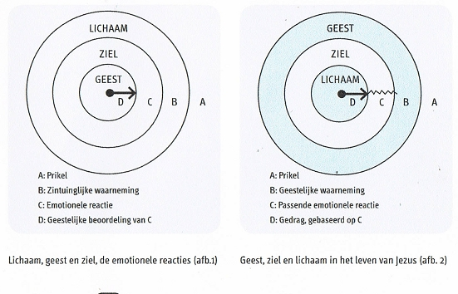

Picture 1 Body, Soul and Spirit
A: Stimulus
B: Sensory perception
C: Emotional response
D: Spiritual judgment of C

Picture 2 Spirit, Soul, Body
A: Stimulus
B: Spiritual perception
C: Appropriate emotional response
D: Behavior, based on C

Emotional responses
In order to give you some idea about the relation soul/body, the model of Marshall may give some clear indications.
1)Through our senses we somehow receive a stimulus. Imagine that we see the neighbor with whom we had a quarrel last week. We then have stimulus A, the neighbor, and then the sensory observation B, seeing the neighbor.
2)The sensory observation, seeing the neighbor, triggers an emotional response.
This can be irritation, confusion, anger or grudge. We remember what he had said. We think about what we should have replied, but which we did not think of at that very moment.
Finally, our spirit, in the function of our conscience, tells us what it thinks about these fierce emotions: “That is wrong. You ought be angry or bear grudges about your neighbor”.

The perfect response to fierce emotions
The problem is that the conscience has to do with emotions, which have already been triggered. When our emotions have been already been swept up and want to turn into deeds, the influence of our conscience is at the weakest.
When you read the gospels, you will see that Jesus was not like that at all. What we consider to be natural, is in fact the contrary. If we want to put back everything in the right place, then we have to reverse it. I discovered that Jesus, in His relationship with people and His environment, lived in the ‘outside’ with His Spirit. In other words: He lived more from His Spirit than from His emotions.

This picture reflects the outreach of our senses. Regarding the sense of our sight, our sense reaches not further than about one meter. Our sense of hearing reaches several meters. Our sight reaches several kilometers. The outreach of our brain is much and much greater.
The outreach of our spirit reaches out to eternity, to the endlessness in God.
Because Jesus as it were, lived with His spirit ahead, He touched every situation with His spirit.
Therefore the emotional responses which made Him act, came out from a spiritual perception. This is very important and we therefore want to corroborate it by the gospels.

In Mark 6:34 we read: “When Jesus went ashore, He saw a large crowd, and He felt compassion for them because they were like sheep without a shepherd; and He began to teach them many things”. So what happened? Jesus ‘saw’ who they were. He not only saw a crowd of men, women and children. He also had a spiritual picture of who they were: sheep without someone to take care for them.
This spiritual picture had an emotional response as a result: compassion.
This led Him to an appropriate act. He started to teach them, and later He gave them food to eat.
Another example is in Mark 3: Jesus went into the synagogue and saw a man there with a withered hand. He said to those who were there: “Is it lawful to do good or to do harm on the Sabbath, to save a life or to kill?”
They remained silent. Maybe they did not know the answer. But the text says further: “After looking around at them with anger, grieved at their hardness of heart, He said to the man, “Stretch out your hand.” And he stretched it out, and his hand was restored.” What Jesus saw when He looked around, were the hard and bitter hearts of the people, who preferred to see the man to remain with his withered hand than that the rules were violated. From that spiritual observation arose an emotional reaction, which in this case was sadness and anger. Driven by these feelings, Jesus called the disabled man to come forward. And in their presence on the Sabbath, He healed the withered hand.
Like that Jesus responded in Luke 19: 41-43 about Jerusalem. Jesus saw the city, but He saw more than the streets and buildings alone. The spirit of prophesy came on Him and He ‘saw’ the condition in which the city found itself and the consequences of its sin and He wept of grief.

“Have this attitude in yourselves, which was also in Christ Jesus”(Phil.2:5).

“Therefore be imitators of God, as beloved children; and walk in love, just as Christ also loved you and gave Himself up for us, an offering and a sacrifice to God as a fragrant aroma.” (Eph.5: 1-2)

The perfect brain function of Jesus
I would like to approach this subject from the neuropsychology of emotional control and identity. In the previous editions of our Promise magazine, we have dealt extensively with the process of emotions in our brains. You can read for example the extensive article on emotional synchronization on our website (1)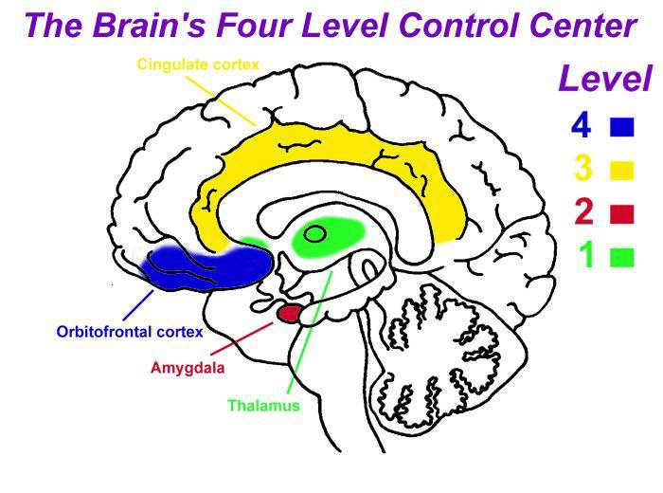

Picture 3: The Control center of our brains. Copyright: Jim Wilder

The illustration shows us the structures of the brain which are often brought in relation with the four levels of the controlling center. There is still some insecurity about the question where some function begin and end, but there are many indications that they are concentrated in places which are mentioned on the map. Level One uses the thalamus which is known as the deep limbic structures such as the basal ganglia.
Level Two mainly takes place in the amygdala. The cingulate cortex contains the mother core of Level Three.
The most attention in science is focused on the orbital frontal cortex of Level Four.
Together these structures are called the limbic system.
Summarized you could say that the controlling center of our brain has the purpose to remind us how we can respond as ourselves in all circumstances.
In other words: here it is about a good progress of the synchronization process between the interior and exterior, no matter what happens.
As soon as something happens, emotions occur such as joy, grief, fright, anger, shame, disgust, desperation and humiliation. Sometimes they happen from the inside and sometimes they are also triggered by others around us.
When our control center is undeveloped and unorganized, the synchronization process does not occur well, which may cause us to lose the control over our lives due to these strong emotions.
We can be ‘overruled’ by strong emotions which can therefore make respond differently from what we would want to according to our identity (see picture 1).
We could therefore respond to aggression with aggression. Or we could get traumatized and damaged in our identity, which is who we are, by emotional overburdening.
If our control center, however, is strong and well trained, we are able to remain ourselves, regardless the intensity of these feelings (picture 2). The preparation for handling all of these emergencies occurs during the first two years of a child’s life, at least, if it is supported by a good mother.
The ability of the brain activity to synchronize carefully is learned in phases.
Thereby each phase forms a level of the controlling center. This structure operates as a great learning machine from below upward. This learning process has mainly to do with the development of a strong identity (Level 4). The first two levels of emotional control have mainly to do with unconscious processes which can cause or trigger all kinds of latent fears and unspecific feelings.

The third level has everything to do with our social skills: how we can consciously synchronize our feelings in interactions with others.
That does not mean that we skip, suppress or ignore our feelings, but we use them to reveal ourselves.
The feelings are therefore used from our identity: who we are and what we stand for. We, however, often come to the conclusion that the identity has been poorly developed and that we respond immaturely or sinfully and we allow ourselves to be guided only by our emotions and not by who we are. the ultimate example of a perfect identity and a perfectly developed emotional control is the Lord Jesus. He suffered intense physical pains on the cross, which must have felt even worse than any other person would have, because of His delicately developed perfect feelings. In addition He also experienced enormous psychological pains. After all, He was betrayed; abandoned by His disciples. He was mocked, spat upon His face and was challenged to deny Himself. The devil made a last attempt to frighten Him and to release His identity. At the cross He saw Mary whose mother’s heart was pierced. The ultimate mental pain of Someone who had always walked in relationship and communication with His Father in heaven, was tested in an ultimate way.
On the cross He cried out: “My God, My God, why have you forsaken Me?”And in all these emotional hurricanes and tsunamis the Lord Jesus remained the same. He did not respond from his emotion, but from his identity:
“Father forgive them.” A perfect response from a perfect man. Even on the cross He did not get traumatized, but remained to be Himself (pic. 2 and 4).

Jesus, led by His Divine Nature in His emotions
Jesus was totally human and totally God. During His life on earth He never served Himself with His God-Being, which implies that in the troubles of life as man He never made it easier for Himself by calling on His Divinity.
In the Epistle to the Philippines it is said: “Who, although He existed in the form of God, did not regard equality with God a thing to be grasped, but emptied Himself, taking the form of a bond-servant, and being made in the likeness of men. Being found in appearance as a man, He humbled Himself by becoming obedient to the point of death, even death on a cross” (Phil. 2: 6-8).
As totally man He lived without sin, and let Himself to be guided by the Holy Spirit, during all His life on earth.
Therefore, because of His perfect life, He was a perfect offering and in His resurrection a perfect mediator.
In His resurrection as perfect Man and perfect God, He has made everyone who in this time of grace is willing to give his or her life to Him, related to Him.
In the second epistle of Peter we see how He as the resurrected Lord, wants to guide people by His divine power.
We see as it were, a blueprint of a perfect development in growth and maturity.

Earlier in this article I have discussed the perfect body language and emotion of Jesus and His perfect responses and behavior in the stress of life. We have also gazed in the perfect process of His brains when it comes down to relationships of thinking, feelings and identity. Finally I would like to take a look from a biblical view in the perfect development in which Jesus has been a living example for us as man, wherein He perfectly was guided by the Holy Spirit, and wherein He wants to guide us and let us share: namely in His divine nature.

In 2 Peter 1: 3-7 it is said: “His divine power has granted to us everything pertaining to life and godliness, through the true knowledge of Him who called us by His own glory and excellence. For by these He has granted to us His precious and magnificent promises, so that by them you may become partakers of the divine nature, having escaped the corruption that is in the world by lust. Now for this very reason also, applying all diligence, in your faith supply moral excellence, and in your moral excellence, knowledge, and in your knowledge, self-control, and in your self-control, perseverance, and in your perseverance, godliness, and in your godliness, brotherly kindness, and in your brotherly kindness, love”.

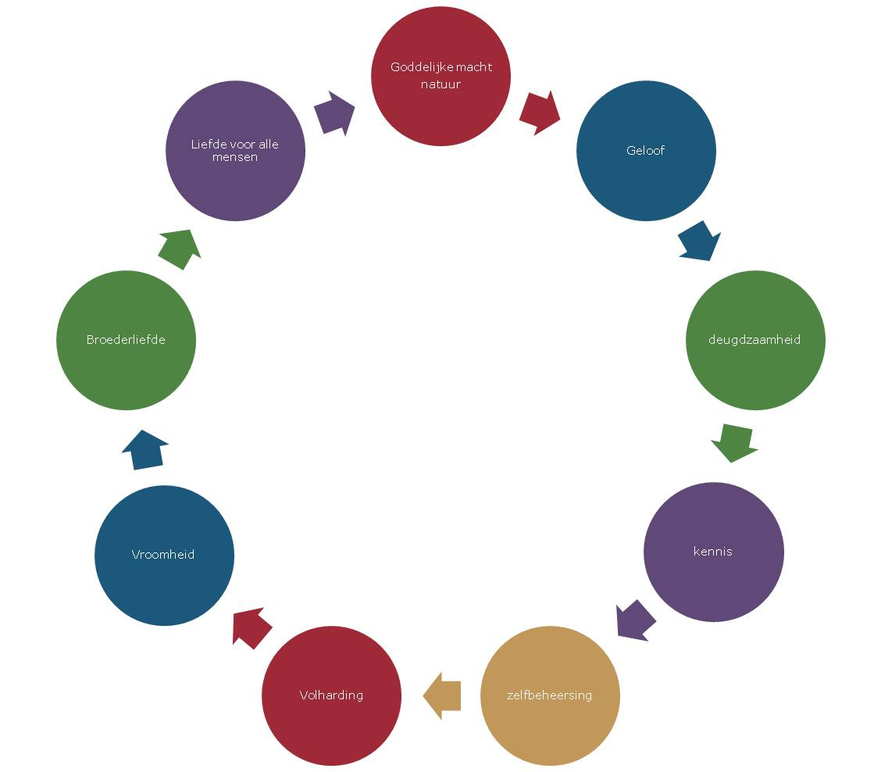

In this schedule we find an itinerary of the sanctification of a born again man, who through the possibilities of God, can develop, and can live up the life of Jesus.
But at the same time we see that this is the way how Jesus ‘has learnt’ perfect obedience without sinning.
It starts with the faith in which the autonomous man must submit himself to the almighty God and from that point becomes a new creation and receives a new identity. The new man has to learn to live from that new identity and to make choices and not allow himself to be led by his old autonomous nature.
As we have seen in the brain physiology, namely that a man should not let himself be led by his feelings but must be led by his identity (Level 4), in such a way should man in this schedule be practicing faith in times of trouble and stress in life, in his new identity.
If you start to live from that divine nature and let yourself be guided by Jesus, you will become a sound man.
That is a faithful person, someone you can rely on, a man who has learnt to think differently, namely as Jesus teaches and prompts us.
We develop other feelings and another attitude; we gradually change to the image of Christ.
That leads us to the next step: knowledge. Not only intellectual knowledge, but knowledge in the sense of the old concept of knowing. Just like when a boy and a girl fall in love and build up a life together, get to know one another better and better. The knowledge of God in relationship with Him is communicating with God, open yourself to His Word and Spirit. Let His voice in your heart be the arbitrator, like it is said in the epistle to the Colossians. Knowledge through your heart, prompted by the Holy Spirit. If you learn to know God in your life, also in secret, you are able to control yourself. This is the next step in the row. Self-control without God is impossible in the troubles and struggles of life. Freud and many others have already noted: in times of trouble a man lets himself to be led by his urges and survival instincts, which is often at the expense of others.
The identity of the natural man is so weak that it leads to inappropriate, sinful behavior in difficult circumstances.
But in this row we learn self-control through the power and the insight of God’s Spirit in the divine nature.
The next stop is perseverance.
In a life where man often is captured in many addictions and traumas, there is an exit through the divine nature: self-control! In this article I have already drawn the attention to the fact that in our brain the self-control has everything to do with our emotional system.
Due to the development of the divine nature in us, we are able to develop a powerful identity wherein self-control, to remain yourself, not deny yourself in difficult situations, is an important goal.
This is an exercise of our brain, but also an exercise in our spiritual life.
We are to be purified, to remain strong. That is also a process of suffering. Many Christians do not know that the love of God also entails suffering.
How can you say to love God and close your eyes for the suffering of God/
The love of God also means to suffer for God and your neighbor.
Another aspect in which we must remain strong is in temptation. In all times but certainly also in our time, man is being tempted in many ways. Remain to be in the new identity which Jesus has given you. Exercise through trials and error, involves a process of perseverance, which is the next step in the divine nature. This does not mean that you should eliminate or deny your emotions, but to allow, in full consciousness, your behavior to be led by the life (and the emotions) of Jesus in your new identity.

The next step in the process is devoutness, or with an old-fashioned word: godliness. This whole process leads us to the fruit of the Spirit in our lives. We have already dealt with one fruit namely: self-control. Other ones are: love, longsuffering, patience. That very love, that very godliness, which will become part of your character. Look at Moses who was called a gentle man; not when he killed an Egyptian man, but when he later had learnt to allow himself to be led by God in very difficult circumstances. In the text portion of this epistle it is continually emphasized in this process: “applying all diligence!, make efforts”. In other translations we read “Therefore, be all the more diligent”. And then … something surprising follows, something we may probably have put in the very front of the row, namely brotherly kindness. Brotherly kindness is a term which is often abused by Christians, because this brotherly love is not always formed by that divine nature. You can only love your brothers and sisters truly if you have made these steps in the divine nature, for otherwise it will be empty words. The final step which is mentioned is (the) love (to all people). That is a love which we do not have by nature.
One of the beautiful things in my work, and maybe you also recognize that in your own work situation , is that you sometimes experience a deep love of God towards another person. That you, as it were, look at the other person with God’s eyes, regardless the difficult situation wherein the other person is involved sometimes. When I experience it, I know that it is a divine gift and that this is the reason why God has created us for, to receive His love and to pass it on.
To this whole process of development in the divine nature, the precious promises for now and in the future, are related.
Promises about which Paul says: “I pursue it”, not for his salvation, which he already possessed in Christ, but for the crown to the honor of God!

How rich is God’s Word! How great are the possibilities in and with the life of Jesus. he is the perfect man and God who wanted to lead us on a way of eternal and precious happiness!

Gerard Feller
November 2012

Translated by Ursula Moestafa

Notes:
- The cited article is ‘Emotional synchronization’, to be read on the internet via http://www.stichting-promise.nl/artikelen/jim-wilder/emotionele-synchronisatie.htm
Over de neuropsychologie van onze hersenen in relatie met onze identiteit, kunt u ook lezen: ‘Met vreugde man zijn’, door dr. J. Wilder ISBN: 9789079011018, ook verkrijgbaar in onze webshop of via www.archippus.nl/index.php
2) Zie ook de artikelen op onze website www.stichting-promise.nl over Jezus als volkomen mensen volkomen God

