Body language
by Gerard Feller - translated by Ursula Moestapa
Recently greater priority has been given to body language in the advertising world, in politics and in business life as well. Any self-respecting ‘trainer’ is investing more and more in nonverbal communication in his executive and management training programs. Except for the hideous excesses of the American television preachers’ culture, body language has been a neglected territory with Christians, yes, it’s often even taboo. Yet, it is the Bible in particular, that teaches us that the essence of man is a tri-unity that is manifested into spirit, soul and body.
Researchers like Mehrabran and Birdwhistell have by now satisfactorily proven that approximately 80 percent of all communication takes place via the ‘nonverbal channels’ of voice nuances, the changes of attitudes and the involuntary movements of the body. Is this also a Biblical fact? Is it not true that the power of speech of Gods Word is often negated by Christians with whom this word has barely worked through in their own soul and body? Or, is the attention to body language only a danger which causes people to (re)present themselves even more differently in order to get a better look and charisma, which may lead them to ‘gain more success’ in the world of power and appearance. In this article we want to provide an impetus to give body language a ‘balanced place’ within the Biblical human image.
DEFINITION
The language of the body comprises every conscious or unconscious movement of the body or part of it, with which it conveys an emotional message to its environment. The body language for emotions such as joy, furiousness, mourning, interest and surprise, fear and anger, dislike and despise and shame has always been equal everywhere across the borders of the world’s oceans. That is the conclusion of the American researchers Friesen and Sorensen. These signals are a collective ‘world language’, but there are also ‘dialects’. For making a right integration of wordless language, people must consider the differences in culture and environment.
One of the most common mistakes in the explanation of body language, is the forming of a judgment based on the separate signs. Body language has its own speech arts and punctuation. And just as with words, body language can, when taken out of context, have the most different of meanings. Observations with children that are blind and deaf from birth who’d never had the opportunity to see signs, prove that both inherited and learned signs exist and the last has changed fundamentally as a language throughout the thousands of years that it has been spoken.
Some signs remail the same all over the world and through time. They are the inheritance of humanity, just like the smile. Admittedly, under stress it has not always been easy to expose the teeth. The former American President Carter, known by his seasoned smile from ear to ear, had clearly lost political conviction during his four-year term of office. Sharp observers have seen the initially optimistic smile of ten teeth reduced to seven when leaving the White House in 1981.
CAN THE BODY LIE?
The higher one stands on the hierarchy of power, the more modest are his signs.
The lower he stands, the more ‘wordy’ he is. As we get older, we slow down our body language. Power and old age reduce the signs our body and face make. When a child lies, it covers its mouth with its hand. Although we don’t lose this unconscious sign, it changes as the years go by. When an adult lies, his sub-conscience gives him the command to withhold his ‘words’. His hand goes to the nose, as if it’s itching.
With other signs it doesn’t works that way. We have the most difficulties when someone can see us closely. Micro signals that we cannot control anymore, like raising an eyebrow, or pulling the corner of one’s mouth, narrowing pupils. These are all indications that can contradict the super signal of honesty, the open hands.
Because young mothers can only communicate by the means of body language in the first years of their children’s life, many women have a more developed ‘sixth sense’ for signs. Politicians and businessmen are only able to ‘falsify’ their body language, in spite training or skill. Actors, professional liars, must stylize and accentuate their movements on stage by the distance of the audience. On the television and movie screen, these movement work grotesquely in close-ups. That requires a more subtle body language. If you want to learn body language, you should spend time learning the signs of others. Places where body language is the primary thing, are places with time pressure e.g. on the airport and terminals. Happiness, joy, impatience are often uncontrollably visible.
TERRITORY
One of the most important subareas of the body language is the so-called proxemics. That is the study of the using of space around us. Most of us are rarely aware of this, although it is very important. Dr. E. Hall, professor in Anthropology, developed a number of scientific theses on this. He made a distinction of four space zones in which most people operate.
1) Intimate distance (15-50 cm)
In this space distance children are hanging on to their parents. It’s the space distance where people are making love and are very aware of the presence of the other. Males can feel unconsciously uncomfortable within such a distance. The classic example is an overcrowded elevator or train in which we automatically regard certain behavior rules. In such case most people will hold back and try as much as they can, not to touch their neighbors. If they do touch them, they draw back or strain their muscles in the touching space with the other person. ‘I’m sorry I touch you, but I can’t help it.’ If one would relax in such a situation and have (physical) contact with the other, he would make a huge fool of himself, socially speaking. This also goes for too long eye contact in the elevator. Looking at each other for too long is considered a breach of privacy and is often translated with dishonorable intentions.
2) The personal distance (50-75 cm)
This is when you can just barely grab your spouse’s hand. The distance is so small that it’s possible to have a conversation. With the distance that you keep in a conversation, you declare in body language the relationship that you have with the other person. The further away, the less sympathetic.
3) Social distance (120 – 490 cm)
This is the space for impersonal business. A boss can use this distance to dominate his employee that is seated. A desk worker can go on with her work from this distance, without the obligation to talk with the visitor who is waiting. With a smaller distance it would be rude to do this.
4) The public distance (4-8 meters)
These distances of human interaction is used in more formal meetings like lectures or speeches. On such a distance it is also easy ‘to lie’ with body language.
Regarding the defense and the intrusion of the zones and the body language attached to it, many books have been written. How ‘aggressive’ a person responds to the intrusion of a zone, is also dependent on the ‘rank’ of the other. The greater the dominance, the more ‘intruding body language’ will be accepted. This is the result of the research in a psychiatric hospital where people are probably more receptive for the suggestion of the body language with which patients with ‘aggressive behavior’ were dominating others. They were in turn dominated by the guards. But also in body language, their responses to the nurses and physicians were even more submissive. In that way, people can also display a clear dominant appearance by subtle body movements.
BODY LANGUAGE AND BUSINESS LIFE
In modern personal training courses it is taught how people can develop more ‘appearance’ or more dominance, by the exercise of body language. How do you shake hands with someone? Not with a limp hand or a pulling hand; not with a distracted look or with the feet turned away, but fully aware of your own personality and possibilities! How long do you look at someone? Dr. Birdwhistell gives 23 degrees of the closure of the eye with the emotions that go along with it. If you distract your eyes in a conversation, you don’t want to be interrupted, or you may be shy, or possibly uninterested, or are you hiding something? When you meet someone on the street, you’re allowed to look at him if he is on a distance of up to 2.5 meter away from you, until you pass him.
On which side the 2.5 meter is determined?
The first impression it said, is determines how you are ‘graded’ by the other. Body language plays a major role in this. Thus ladies: ‘Never cross your legs’; ‘never pull your feet underneath you, take care of a perfect ‘hairdo’ and make-up, walk with a good torso rotation and settling of the foot, with a lifted head and when walking by turns with the head to the left and to the right.
Everything in your body should express: I feel great, I have all things in control, I am great, cool, no matter how you really feel!’
Apart from sales training courses in body language, there is currently also a mass run on courses like: how to flirt with body language, etiquette and the ‘ultimate limit’ in this area. Courses body language and ‘small talk’. Here it is taught how you should move at cocktail parties and talk about NOTHING. You’re not allowed to talk about politics, religion, literature or something that may have some substance, for in that way you could turn the other person away. On the other hand, you must be able to talk for hours about food, about the wine, the weather, the entourage and everything in your body must express again: ‘I am awesome’.
BODY LANGUAGE AND SOCIAL ASSISTANCE
There are many expressions in idioms that are related to body language.
E.g. Having a burden on your shoulders, rolling up ones sleeves, keeping an eye on something, on bended knees, etc. They always express the relationship between body language and emotions. Someone who is always unhappy and looks like that, will get a worry wrinkle from it. Someone with an aggressive nature has the habit of constantly stretching his chin forward. It seems that a lot of chronic emotions are ‘freezing’ in a physical behavior. Alexander Lowen, the founder of the bio energetics, goes even so far as to say: ‘You are what you feel’. This is how he achieved the so-called physical dynamics of the character structure. Take for example the attitude of the shoulders. When they are somewhat drawn back, then it implies the controlled anger. Raised shoulders attest to fear. Square shoulders can bear responsibility and bended shoulders bear heavy burdens. Although Bio energetics are fully permeated with the Freudian thinking, body language may also be an important element in the Christian Social Support, provided that it is embedded in the Biblical human image and thinking.
For example, there is the case of a neurotic introvert girl of 14 years that’s questioned by a therapist. The girl is sitting at the table with her head bowed, her face hidden, her left-hand over her eyes, her right-hand slips over the table to the therapist and back and she doesn’t respond to any of the questions she is asked. She is actually ‘crying’ for a touch, but the therapist does not go any further than a verbal approach. Only in the second conversation, when the therapist caressed her and touched her at the same attitude, openings were created where the child could express herself verbally and emotionally. I myself often have the experience that praying and talking sometimes seem to be blocked and that dealing with body language offers openings which can cause a breakthrough in other areas of support.
In the book ‘Biblically dealing with physical tensions’ I have described amongst others some tension signals in breathing. In the secular support, the so called Gestalt Therapy was developed in this way by Dr. Perls, where clients are also confronted with their body language. For example, you’re always laughing when you’re afraid or when you are hard pressed, how come?
As already said, the signals of the body will be used as valuable information within the interpretation of the relations of spirit/soul/body. Dealing with this requires a (the) compassionate heart of Christ, in which we can more and more empathize with the thinking and emotions of the other, in order to meet him from the love and wisdom of Christ.
JESUS, FULLY MAN, FULLY GOD
In the Lord Jesus there is no sin; His body is in a fully open perfect relation with His soul and spirit. John calls the acts that Jesus did SIGNS that should be metaphors of His spiritual life (John 2: 11; 20: 30). These signs are not sorceries, but are always in the service of spiritual and moral purposes. They serve His love. The deep inner coherence between physical and desperate need were never separated with Him. He has felt both. The serving love controlled His actions.
Take for instance the touching of the sick. In those days a person who was mute and deaf, was more an object of disqualification than of pity. Jesus approaches people with a loving heart and a gentle touch (Mark 7: 33). Jesus’ meaningful touching of the sick, especially the blinds and the mutes, were full of love for those who could not see or hear. How much warmth of affection and love must His hands have radiated to the dead little girl that was lying on the bed (Mark 5: 41). In those days, the touching of a dead person was a great form of uncleanliness. In this view, Jesus’ love was also victorious.
Time and time again, people have formed thoughts regarding the figure of Jesus.
In Ps. 45: 2 it reads: ‘You are fairer than the sons of men’. In Isa. 53: 2 it is said in another time that He has no form or comeliness. His body language was not contrived, but fully in agreement with His sinless soul. When He was arrested, the law officers drew back because of His ‘body language’ of the combination of his word, his glance and his figure (John 18: 6). With the Scribes and Pharisees, He sensed their numbed conscience by glancing at them when He healed the man with the withered hand (Luke 6: 10). How fiercely did his anger burn, which again made room for deep grief (Mark 3: 5). In Mark 10: 23 His eyes were cooperating when He was instilling in the apostles the dangers of wealth. Then in verse 27 there’s again a glance to comfort them and to emphasize that with God nothing is impossible.
Jesus knew the power of His eyes. During the night of the betrayal, Jesus led Peter by His eyes to the redeeming exit of deep remorse (Luke 22: 61). With an open eye He observed natural phenomena. He saw the sparrows on the roof (Matt. 10: 29), the flowers in the garden (Matt. 6: 28), the tailor fixing garments (Matt. 9: 16) and the children (Lk. 7: 32). He had perfect metaphors, fitting Someone Who had a perfect body language. He let the disciples of the Pharisees hand Him the denarius (Matt. 22: 19). He puts a child in the middle (Matt. 18: 20). He points with His finger to the lilies in the field and the birds in the air (Matt. 6: 26, 28), to the fishing net on the sea shore (Matt. 13: 47) and to the Sower and the field (Matt. 13: 3).
He illustrates what He’s teaching by metaphorical actions. The apostles had to learn to be the least. Therefore He took a towel and a basin and washes their feet (John 13: 14). They had to know that was going to die. He breaks the bread which is the sign of His body, before them (Matt 26: 26). They have to know that He will die for them and therefore He reaches out the bread to them, so that they could eat it. They had to know where He would be, therefore He ascended to heaven before their eyes (Acts 1: 9). The ‘radiation’ of Jesus was always of compassion, love and mercy. His gentleness and goodness caused parents to bring their children to Him so that He could touch them (Matt.18: 12). A sunny cordiality has always escorted Him in all His ways, and although Judas would betray Him with a kiss, He blamed Simon for not giving Him a kiss (Luke 7: 45). The ancient eastern way of connecting a greeting with a kiss, became a Christian custom (Rom. 16: 16, 1 Cor. 16: 20, 1 Pet. 5: 14).
THE PERFECT EMOTIONAL RESPONSE
In order to indicate something about the right relationship of the soul and body, the diagram that Marshall gives might be clarifying (TOM MARSHALL: Freed to be free; Gideon 1992):
- Through our senses we receive an impulse. Assume that we see our neighbor with whom we had a quarrel last week. We then receive impulse A, which is the neighbor and then B, the sensory perception, which is the sight of the neighbor.
- The sensory perception, the sight of the neighbor, arouses an emotional response. This can be irritation, confusion, anger or vengeance. We remember what he said to us. We think about what we had to reply, but which we did not at that moment…
- Finally, our spirit gives us its meaning about these fierce emotions, in this function of our conscience: ‘That’s wrong. You’re not supposed to be hateful towards your neighbor.’

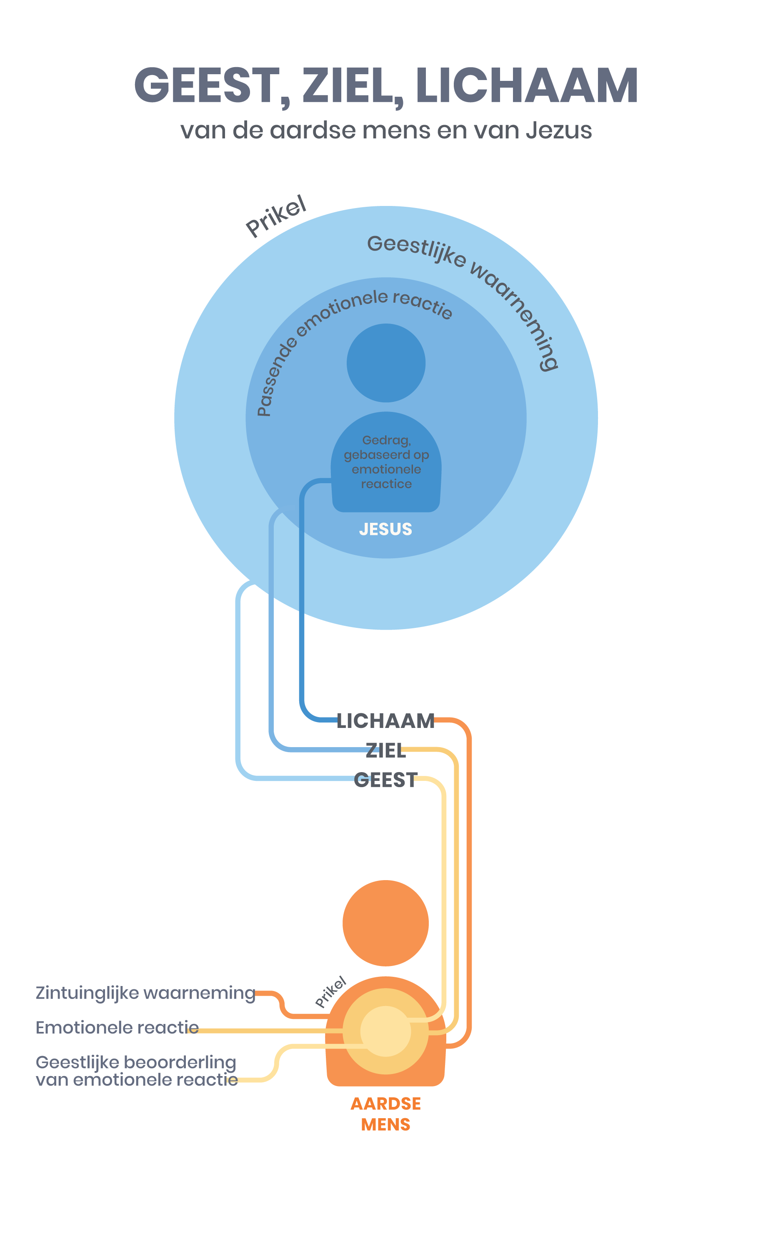
SPIRIT, SOUL, BODY: THE EMOTIONAL REACTIONS
The problem is that the conscience has to deal with emotions that have already been aroused. When our feelings are so excited and want to move on to actions, the influence of our conscience is the weakest. If you read the gospels, you’ll see that Jesus didn’t act like that. What we consider to be natural, is actually the contrary. If we want to put things in the right place, then it should be reversed. I have discovered that Jesus, in relationship with the people in His surrounding, lived with His Spirit at the ‘outside’.
SPIRIT, SOUL AND BODY IN THE LIFE OF JESUS
Our sense of touch doesn’t go further than a meter. Our hearing reaches a number of meters. Our sight capacity reaches a number of kilometers. The range of our intellect is much and much larger. The range of our spirit reaches out to eternity, to infinity and God. Because Jesus, as a matter of fact lived with His Spirit at the front, He touched every situation first with His Spirit. The emotional reactions that made Him act, therefore stemmed from a spiritual observation. This is so important that we should measure it by the gospels.
In Mark 6: 34 we read: ‘When Jesus went ashore, He saw a large crowd, and He felt compassion for them because they were like sheep without a shepherd; and He began to teach them many things.’
What happened? Jesus ‘saw’ who they were. He not only saw a crowd in men, women and children. He also had a spiritual picture of whom they were. Like sheep without having someone to take care of them. This spiritual picture resulted in an emotional response: compassion. And this caused Him to take the appropriate action. He started to teach them, and later on He gave them food to eat.
Another example we read in Mark 3. Jesus entered the synagogue and saw a man there with a withered hand. He said to the crowd: “Is it lawful to do good on the Sabbath or to do harm, to save a life or to kill? But they kept silent”.
Maybe they didn’t know the answer. But the text further says: “After looking around at them with anger, grieved at their hardness of heart, He said to the man, “Stretch out your hand.” And he stretched it out, and his hand was restored.”
What Jesus saw when he looked around, were the hard, bitter hearts of men that rather saw that a man remained deformed than that the rules were broken.
From the spiritual observation an emotional reaction aroused, which in this case was sadness and anger. With these feelings as a motivation, Jesus called the handicapped man to come forward. And in their presence on the Sabbath, He healed the withered hand.
This is how Jesus responded in Luke 19: 41-43 about Jerusalem: Jesus saw the city, but He saw more than streets and buildings alone. The spirit of prophecy came upon Him and He ‘saw’ the condition in which the city found itself and the consequences of its sin, and He wept with sadness.
We hope to write some more articles about the relationship spirit/soul/body in the future, Lord willing.
Philippians 2: 5 ‘Have this attitude in yourselves which was also in Christ Jesus’. Ephesians 5:1-2 ‘Therefore be imitators of God, as beloved children; and walk in love, just as Christ also loved you and gave Himself up for us, an offering and a sacrifice to God as a fragrant aroma’.
LITERATURE:
Lichaamstaal (Body language) – Erhard Thiel – Helmond 87
De taal van het lichaam (The language of the body) - J. Fast - Servire Katwijk '87
Mens en territorium (Man and territory) - Ashcraft/Scheflen - Bruna 79
Depressie en het lichaam (Depression and the body) - A. Lowen Servire - Katwijk 88
De naakte mens (The naked man) - Desmond Morris - Elsevier '82
Gebaren (Signs/gestures) - D. Morris - Bruna 80
Grondslagen interpersoonlijke communicatie (Basics of interpersonal communication) - Giffin/Patton - Loghum Slaterus 81
Bevrijd om vrij te zijn (Freed to be free) - Tom Marshall - Gideon 92
Hoofdstuk uit het boek Bijbels omgaan met stress deel 1 lichamelijke aspecten (Chapter from the Book ‘Dealing with stress Biblically Part 1 Physical aspects

