Spiritual Diagnostics

By Gerard Feller 2025
Introduction
Healthcare diagnostics are increasingly recognizing the relational and process-oriented aspects of the human being. This is a positive development, as it moves away from the reductionist approach that views individuals as machines in need of repair when experiencing symptoms. While every self-respecting healthcare worker theoretically rejects this reductionism, practice often differs. Despite interdisciplinary consultations, care protocols, and expert training, thinking about health remains limited. Complaints and illnesses are still divided into "somatic" or "psychic." The nearly one million chronically ill and disabled people in the Netherlands often fall prey to this mindset. Those considered "psychically" ill often strive for "somatic" recognition in patient and advocacy groups, as this is often perceived as more acceptable than something "between the ears."
Increasing brain research shows that almost everything is "between the ears," but in a different way than commonly thought. All neurological, psychological, hormonal, and organic interactions are interactively and hierarchically coordinated by our brains. Modern brain research seems to blur the lines between our "hardware" and "software." There's a growing search for a human model that can provide a framework for this thinking and diagnostics. Modern health psychology increasingly focuses on the relationship between psyche (and mind) and body. Unfortunately, this thinking is often informed by Zen or Taoist philosophy due to the extensive publications from these schools of thought. Christians, who from a biblical perspective should know much more about these relationships, lag behind. The Bible is not a medical textbook, but it contains much about God's intentions for humanity. Biblically, health is understood relationally: the relationship with God, fellow humans, nature, and the internal relationships between spirit, soul, and body (Gen. 2:7, Gen. 2: (?), 1 Thess. 5:23). Many Christian healthcare workers know that the Bible distinguishes between the psyche and the spirit of man, yet this knowledge has barely found its way into their diagnostic practices.
Measurement equals knowledge
In a conversation last year with several Christian psychologists, it was indicated that they did not take the spiritual world and people's position within it into account in their diagnostics, simply because it is hardly measurable. They acknowledged that there are many excesses in this area. On the one hand, there is a belief that spiritual life has an important relationship with what is called "psychological suffering." On the other hand, it cannot be objectified, and therefore nothing is done with it. Indeed, we should exercise great humility in this area, as only the Spirit of God can guide us so that we can compare spiritual things with spiritual things (1 Cor. 2:13). For example, it is clear that sinful behavior can also cause various complaints (Ps. 32:4). It is also clear to every Christian that our spirit, awakened to life, must be cleansed and defended against the fallen spiritual world around and within us. Often, there is monocausal thinking where spiritual health does not take into account biological or genetic deficiencies, traumas, or psychosocial weaknesses. For example, in a sprained ankle, spirits may be cast out as the "sole" cause of the trauma. Because of this immense complexity of human creation, many Christians also fall into reductionism, where they not only deny the influence of evil but also unintentionally often forget the positive, healing, empowering, gracious, and blessing influence of God through Jesus Christ. The possibilities of resisting Christian caregivers hide behind secularization in healthcare but forget that, on the other hand, Taoism, Zen, and New Age spirituality are gaining ground and increasingly integrating into mainstream healthcare. As a starting point to counter this "corruption," I would like to briefly mention a number of benchmarks that provide insight into spiritual life and that, to a certain extent, can be measured more or less through questionnaires and conversations.
Engel's Scale
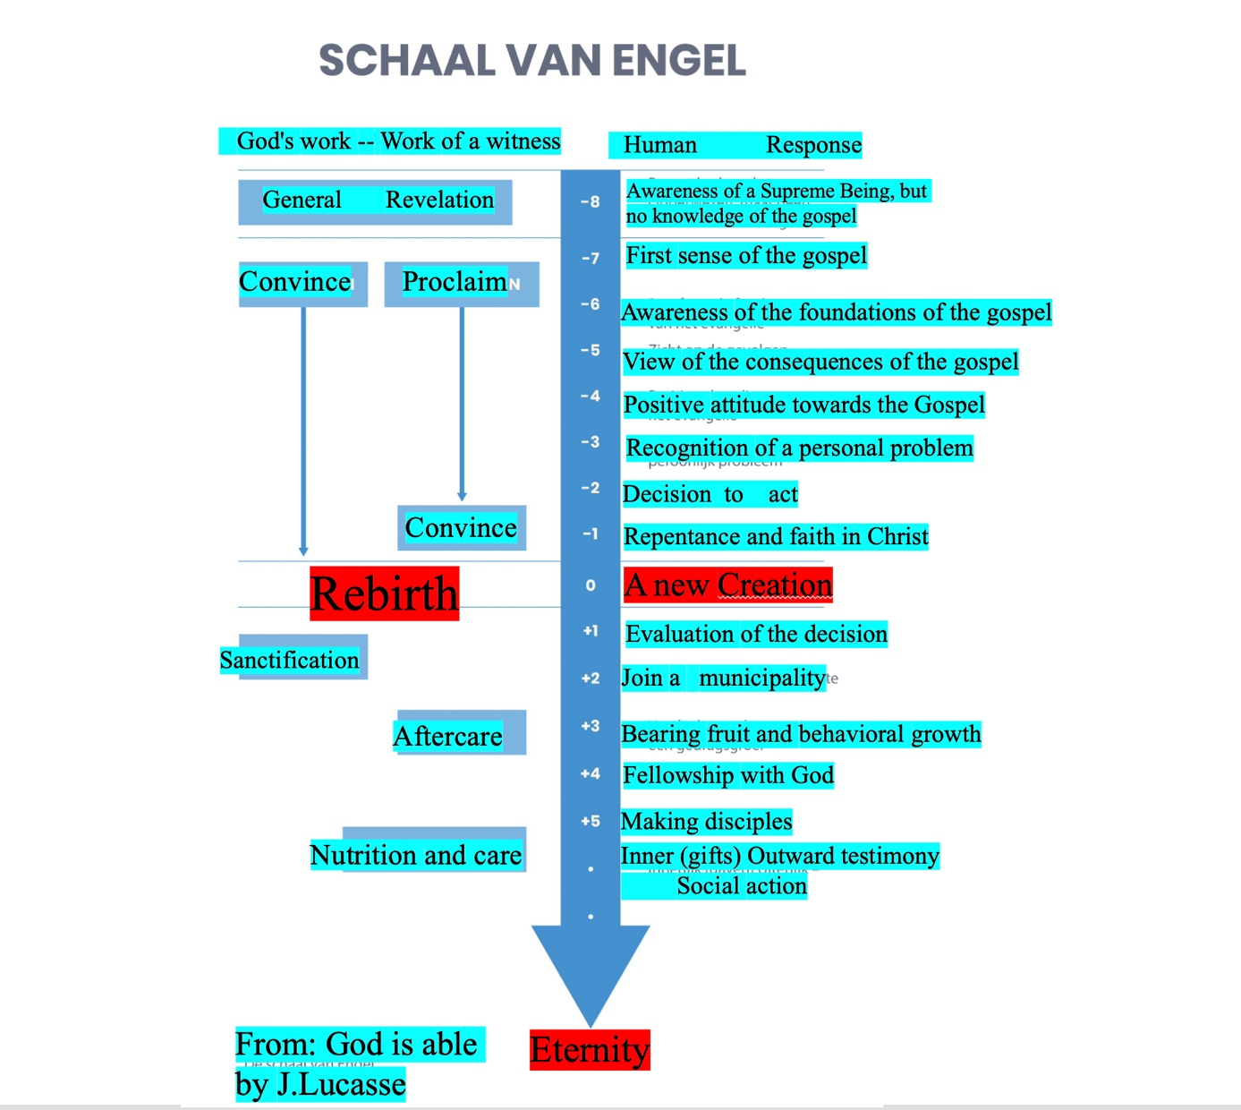
One of the first measuring instruments I saw was Engel's scale, published by J. Lucasse in the book "God is Able." The zero line of measurement is rebirth, the certainty of faith, and being a new creation in Christ. The scale provides insight into the process, which is indicated in eight steps to reach that rebirth. Then, in five to eight steps, insight is given into how this faith can integrate healthily into that person into a healthy, psychosocial being, focused on God, fellow human beings, and nature as God intended. Of course, you cannot immediately draw medical conclusions from this, but it indicates how you can determine a spiritual position.
Questions regarding the image of God
The conscious or unconscious interpretative framework of how one places oneself or one's complaints is strongly dependent on three factors: the image of God, the image of man, and the worldview. To measure someone's spiritual health and the influence this has on their complaint pattern, we will need to do more research into someone's image of God. The Bible states that we come to know God through Jesus.
The Holy Spirit and the Bible, the Word of God. The question: "Who is God for you now?" is a very important one. Some will answer this question according to what they think the therapist's expectations are; others from their feelings at that moment (depressed clients); still others from their upbringing and cultural background (father image). Others will clearly indicate their spiritual position (see also Engel's scale). Often, one already comes into contact with "the spirituality of others." And often one will also hear: "He means nothing to me," or "I would like to get to know Him." Rom. 1:22,23 also gives a number of possibilities:
"Claiming to be wise, they became fools, and they exchanged the glory of the immortal God for images resembling mortal man and birds and animals and creeping things."
Because the question 'who God is for you now' can be answered in numerous ways, it is important to test these against biblical criteria.
The second question should then be: "Who is Jesus Christ for you now?", "Does this differ from the past and how?". Jesus Christ is God who also became man and who is the expression of the essence of God. ((Hebr. 1:3; John 14:1,11; John 17:2)
The third question about the image of God can then be: "In the Bible, the Lord Jesus has many names and titles; highlight 5 topics from the list below that appeal to you most in Jesus".
"Which name or title appeals to you most about Jesus Christ?".
Redeemer | Messiah | Son of God | Rabbi | Judge
Light of Life | Word of Life | Creator | High Priest | Forerunner
God and Man | Eternal Father | Brother | The Way | The Truth
The Life | The Resurection | The First and Last | The Righteous one | The Chosen one
The High Holy one | The Vine | The King Lord | Lord of Hosts | The Lion of Judah
Son of Man | Sun of righteousness | Son of David | Morning Star | Bread of Life
The Firstborn | Lamb of God | Friend | The Door | Ruler
Source of Life | Grain of Wheat | Master | The Promise | Servant
Prince of Peace | Strong God | Wonderful Counselor | Elohim | Adonai
Jehova | Overcomer | Suffering Servant | The Christ | Rock of Foundation
The Cornerstone | The Anointed One | The Salvation of God | Grace God’s | Perfecter of Faith
Wisdom of God | Head of the Body | Firstborn | The Beginning | The Bridegroom
The Beloved | The King of Ages | Image of the invisible God | The Mediator | The Savior
The Teacher | Radiance Glory of God | Prince of Life | Faithful and True Savior | The Almighty
The Truth | Son of God | God Rabbi | Light of LIfe | Word of Life Creator
High Priest | Son of David | The Truth | One other such as:
Has the respondent had experiences in his life that he attributes to God, and if so, which ones, how has he interpreted them, and what meaning do they have for him in the here and now? Does he see himself as bad or good, as lost or accepted, passively dependent on God's grace or with his own given possibilities and will to develop these together with God and others? Does he think in black and white, if so, about what? does he have to be able to do everything perfectly himself, or is there room for growth, relationships, openness, giving and receiving?
Questions regarding the Holy Spirit
These questions are mainly relevant to the communication that clients experience in their relationship with Jesus Christ.
• What does the Holy Spirit mean to you now?
• Do you pray often, and are prayers answered?
• Which prayers do you pray most? (see diagrams).
• Do you have dreams, visions, images that you think are from God?
• Have you received spiritual gifts from God, which ones? (1 Cor. 12). An extensive gift test has been developed by Christian Schwartz and published by Gideon Publishers in Hoornaar.
Types of prayer
*Seeking the face of God Ps. 27:8 (cf. Rom. 3:11), Ps. 25:11-15, 2 Kings 19:14-15, 2 Chron. 7:14, Neh. 1:4
*Allowing the Lord Jesus into your heart Rev. 3:20, Hebr. 4:16, Hebr. 10:19-24
*Confession of sins 1 John 1:9, John 14:15-17 and 25-27
*Giving God glory Luke 18:10-14, Acts 16:25, Matt. 6:9
*Pouring out our hearts before God Ps. 62:9, 1 Sam. 1:15
*Being still before God Ps. 62:6, Ps. 131:2, Rom. 8:26,27
*Receiving strength Eph. 1:17-19, Luke 22:40,46 Isa. 40:31, Matt. 26:41
*Receiving wisdom Jer. 33:3, James 1:5, Gal. 5:25
*Changing Luke 9:28,29
*Promise to God 1 Sam. 1:11, Ps. 56:13
*Asking for a sign Judges 6:17-21, cf. Luke 11:29-32
Parts of a prayer
*Worship-Praise Ps. 40:14, Matt. 26:30, Acts 16:25, Eph. 5:19, Col. 3:16, Ps. 30:5, Neh. 11:17, Ps. 103, Ps. 50:23, Matt. 6:13, Rev. 5:12,13, Ps. 30:5
*Thanksgiving Ps. 50:23, 2 Cor. 9:12, Eph. 5:20, Phil. 4:6, Col. 2:7
*Supplication Dan. 6:12, Eph. 6:18, Phil 4:6, 1 Pet. 3:8-12
*Intercession For kings, dignitaries 1 Tim. 2:1-4
*For the salvation of people Rom. 10:1
*In distress Acts 12:5, Phil. 1:19
*For healing James 5:14-16
*For the enemy Matt. 5:44, Luke 6:28
*For brothers and sisters Phil. 1:4, Col. 1:9
Forms of prayer
*Personal prayer 1 Sam. 1:10-15, Matt. 6:5-6, Matt. 14:23
*Corporate prayer Luke 1:10, Acts 1:14, Acts 2:42
*Closed prayer Matt. 26:26, Acts 20:31-36 *Open prayer Acts 2:41-47, Eph. 5:18-21
How should we pray?
*In spirit and truth and love John 4:24
*In Jesus' name and according to His will John 15:16, John 16:23-26, 1 John 5:14
*In faith Matt. 17:15-21, Hebr. 11:6, James 1:6,7
*Without hatred and in unanimous love Matt. 18:19,20
*With perseverance Luke 18:1, Eph. 6:18, Col. 1:9, 1 Thess. 5:17
*With understanding 1 Pet. 4:7, 1 Cor. 14:14,15,
*In the spirit 1 Cor. 14:14,15, Jude 20
*Simply Matt. 6:7,8
I prefer that the patient prays himself and thus allows him to experience what this does to him, what thoughts, memories and feelings this evokes in him. Often he can express himself more deeply in prayer than in face-to-face contact with the therapist. His resistances and conflicts also become clearer. The therapist can also discuss this, and this deepens the therapeutic process. In other patients, however, prayer causes a lot of anxiety, or evokes deep feelings in the patient. that they are not yet able to handle. The therapist must therefore be able to assess whether the patient wants this and can handle it.
The therapist can also pray for the patient from a psychotherapeutic perspective. Depending on the patient's capacity, they can choose to pray in a supportive, covering manner, which strengthens the patient's self-esteem, makes them feel less alone, and protects and carries them, using metaphors (images). Alternatively, they can choose to pray in a more insightful, exploratory way, where things are named (e.g., traumas), feelings are evoked, insight is prayed for, and more openly, listening to God and oneself, the matters are prayed through.
If they choose the first form, a follow-up discussion is often unnecessary and undesirable. If they choose the second form, a follow-up discussion is always necessary to discuss what the prayer has evoked, and even during the prayer, one should continually reflect on this. As I said, my experience is that through prayer, used correctly and at the right time as a tool, the contact is deepened, and the patient dares to open up more to embark on the difficult path of self-examination, not alone, but in relationship with God and others. In this way, they learn to know themselves and God more and more, and this experience has become dear to me.
Questions regarding the Bible, the Word of God
*What does the Bible mean to you?
*Is this book legislative, guiding, or a possible example for you?
*How much do you read or study the Bible now?
*Is the Bible a Word of God or a word about God for you?
*Are there texts in the Bible that have a special meaning for you?
Sometimes Bible verses can also be used very selectively and negatively by clients. Colored by their backgrounds and upbringing or by their emotional disorders, they repeatedly highlight the 'negative' texts and often wrongly identify with the greatest sinners or those who have sinned against the Holy Spirit. Others are 'over-spiritual' and are only fixated on positive thinking and, for example, the 'prosperity gospel.' It is important to gain insight with clients into how the spiritual reality has penetrated earthly reality. Is that reality far removed from daily life in the relationships people have in their family, work, church, society, health, finances, leisure, etc.? Kurt Blatter indicates in his book "Stress Part 2, Psychosomatic Aspects" that this is a biblical tension field.

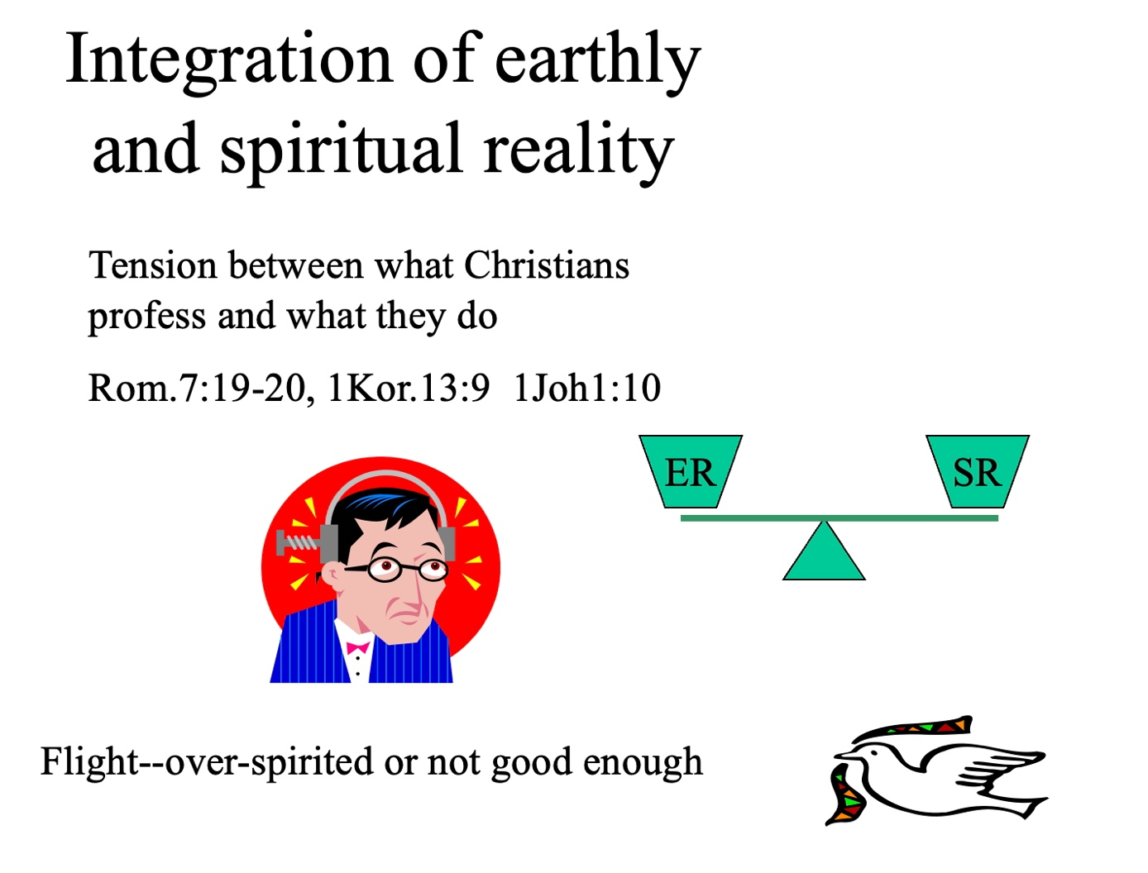
There is a balance between earthly reality (ER) and spiritual reality (SR). We confess that we are citizens of heaven and walk in Christ in heaven, and at the same time, we have a life as residents of this earth. On the one hand, we confess that we are blameless and pure in Christ (Eph. 1:4), and on the other hand, the Bible says that if we say we do not sin, we are lying (1 John 1:8). This creates a tension that some threaten to escape by becoming 'over-spiritual.' They express all sorts of pious texts and say that they experience God's voice many times every day, but everyone in their environment sees that all social and humane duties and relationships in earthly reality fall short. An example of such an escape is someone who has neglected their family and behaves antisocially and selfishly towards their environment, experiencing various tensions, and whose explanatory model for their complaints is that they are being 'spiritually' attacked because we are living in the end times. The scale then tips towards spiritual reality, and there is no balance with earthly reality. For others, the scale tips towards earthly reality; they only see their shortcomings, weaknesses, and sins, and have little awareness of God's grace.
But even in serious illness, spiritual reality can be disturbed, and the sick person may plunge into despair and misery. Moreover, over-spirituality can also occur, and one has little regard for the reality and consequences of the illness. The biblical secret is an integration of spiritual reality into earthly reality or, as Paul says in the letter to the Colossians, we must view the (earthly) things from above where Christ is, for our life is hidden with Christ in God.
Questions regarding the relationship between ER and SR
*Do you have a regular prayer life, quiet time?
*Does God also have a place outside your church life, in your work, family, relaxation?
*Do you experience that God 'speaks' to you, and if so, in what way? Can you clarify in a few words what grace means to you?
*How do you spiritually deal with problems/complaints/stress?
*Do you have insight into God's plan for your life?

The conscience as a spiritual gauge
In modern psychology and guidance, the function of the conscience is often labeled as 'prehistoric' and outdated. Long ago, people dealt with these narrow feelings of guilt and sin awareness. The conscience is cauterized, and the word guilt is replaced by the Hindu concept of maya or ignorance. Precisely because people no longer distinguish between spirit and soul, the conscience is often formulated as a system of norms and values at a psychosocial level, shaped by the influences of upbringing, culture, and the past. Unfortunately, this is how the conscience functions for many people, but in the Bible, the conscience as a spiritual organ has a much higher purpose. The conscience occupies an extremely important place when it comes to the liberation and redemption of the whole person. By exercising the conscience in the relationship with God and fellow human beings, one can also experience communion with God.
A good conscience means that we have achieved a direct goal, but not yet the ultimate goal. Thus, the standard of our behavior grows with increasing knowledge of Scripture and spiritual experiences. Only if we grow in increasing knowledge and also in increasing sanctification will our conscience not accuse us. However, if we measure our past behavior against our conscience today, our conscience will condemn us, even though we had fellowship with God in that earlier situation. The conscience is therefore a mutual standard of sanctification, and if we do not meet that standard, we sin. The Lord wants to tell us so much, but due to spiritual immaturity in our spiritual understanding, He must wait to make things clear to us.
The Lord wants to tell us so much, but due to spiritual immaturity in our spiritual understanding, He must wait to make things clear to us.
The development of the conscience
Every man has a conscience, which is the awareness that one is not allowed to do everything the way he likes to. It is presented in cartoons as an angel sitting on your shoulder, that whispers all kinds of things in your ear. Little children have a conscience already but no impulse control yet. The society, your faith and the education also play a major role in the development of your conscience. With toddlers the prohibitions only apply when the father or mother who has prohibited them to do something, are also there. This is called the external conscience.

Later they will discipline themselves when they do something that they are not supposed to. But despite that, they then still do what ‘they are not supposed to’. Around the age of three years the conscience of the ‘natural man’ that quickly accuses others, develops further, for example the dog that has done something. This is not consciously lying but lying out of fear for ‘the punishment’. Around the fourth year children often know what is allowed and what not, and only at their sixth year, the conscience starts to really develop. Until the seventh year people find it difficult to recognize the difference between fantasy and reality. From the seventh year the child has to learn to develop self control, for example the concept of a delayed reward. An experiment whereby children were presented candy and were told that if they do not touch it for five minutes, they will get twice as much after five minutes. Children who controlled themselves the best, later appeared to be more successful in society. We will show further in this article that self control is also a very important factor in the brain development, the formation of the conscience and the whole life. We speak of self control when one can hold on to the identity of who he is and is able to overcome all kinds of natural lusts, like rampant sex, aggressive and strong emotions, all kinds of passions and selfishness, by acting according to his identity, in spite of all those temptations. In the brain physiology and control of our feelings, the prefrontal cortex is very important and in the case of a strongly developed conscience, it plays a decisive role in the interactions and relationships of the thalamus, amygdale and the cingula, and at the reasoning of man. This should lead to a perfect biochemistry wherein the ‘rewarding neurotransmitters’ such as dopamine, serotonins and endorphins are naturally produced in the right way.

The conscience in biblical view
Biblically, this skill of controlling the impulses is a fruit and a characteristic of the Holy Spirit. After Adam and Eve took from the fruit of the tree of the knowledge of good and evil, the results were ultimately murder and manslaughter and the human race risked to perish because of its own lack of morality and conscience. Knowledge apart from God leads to death, in contrast to knowledge (fellowship, participation in) in God. Knowledge apart from God is characterized in the Bible as foolishness. The fool says in his heart: “There is no God” (Psa 14:1). Through the gospel of Jesus Christ the fool can become wise by the wisdom of God which is foolishness to the world, namely through the cross (1Cor 1: 24,25). With the new birth the Holy Spirit comes to dwell in our hearts, spirit (consciousness) and is related to it forever (Rom 8:35). The precious blood of Christ purifies the spirit of man, his intuition and conscience.
“How much more will the blood of Christ, who through the eternal Spirit offered Himself without blemish to God, cleanse your conscience from dead works to serve the living God?” (Heb 9:14).

When Adam and Eve sinned, they felt guilty and hid themselves from God.
Due to the gospel of Christ we are allowed to boldly draw near to God. In this way Christ fulfills for eternity (according to the ordination of Melchizedek) a High priesthood, wherein He sanctifies our life with His life and blood. Due to that we have boldness to stand before God through the cleansing blood of Jesus.
If our conscience is clean, without unconfessed conscious sins, we can experience full fellowship and a deeply inward joy through the Holy Spirit. “Let us draw near with a sincere heart in full assurance of faith, having our hearts sprinkled clean from an evil conscience and our bodies washed with pure water.” (Heb 10: 22) A bad conscience is continually accused, which causes the fellowship with Christ to be interrupted and paralyzed. When our conscience is not right, our approach to God is restrained, because we cannot really believe that God has nothing against us.
It robs us from the liberty to have fellowship with Christ. Therefore a Christian ought to be purified from accusations in his conscience, fully purified, specifically through the blood (the life of Christ), so that there is no more accusation (Rom 8: 33, 34).
However, if we keep on being conscious of sins, our spirit will be kept focused to eliminate them and there will be no power left to do heavenly things.
When we neglect the voice of the Holy Spirit in our mind, we will become carnal.

Conscience and judgment
: God deals with His children depending on the situation. Because there are different levels of knowledge, something that is hardly a sin for many Christians may be a serious sin for other believers. Therefore, we should not judge one another (Luke 6:36). Only the Father is able to assess our correct level of knowledge. He does not expect mature male strength from infants! Christ does not seek experiences of "old men" from young believers. He wants obedience (in existing knowledge). If the Holy God has not yet made our unconscious sins clear to us, how can we condemn our brother based on our conscience now, who may have a level of knowledge in his conscience that we ourselves had 5 years ago? If we truly want to help people, we should not set detailed requirements for obedience, but continually encourage them to follow the voice of their conscience. If they surrender their will to God, they will receive the light of the Holy Spirit to the same extent and then obey it. When a Christian surrenders his will to God, he responds to the will and expectation of Christ at that moment, so that his conscience is enlightened. We should not become tense and weary ourselves with truths that far exceed our current spiritual "capacity." If we want to listen to Christ today, He takes pleasure in us. Of course, this should not prevent us from exploring the Truth that the Holy Spirit wants to reveal to us.
A weak conscience
We have already established that the standard of our sanctification is Christ and not our conscience. The conscience can be seen as a criterion for our acute state of sanctification. If we listen to our conscience, we have achieved what can be achieved now. Therefore, our conscience holds such an important place in our daily walk. If we do not follow the indications of our conscience, it accuses us. This leads to a loss of peace and a temporary interruption of fellowship with God. Then the question remains: How perfect is our conscience? We have already seen that our conscience is limited by, among other things, knowledge. Therefore, it is important to realize that there is a significant distinction between the standard of our conscience and the absolute standard of the Holy God. In this, we must distinguish two things:
The conscience only touches upon what it knows. This is a part of the full reality and leaves other things (temporarily) aside, which may also not be within the will of the Lord. Christ and also more mature Christians know how imperfect we are, and yet we often continue on our old path due to a lack of light. However, this imperfection is bearable because God does not condemn for it. The limited knowledge of our understanding can lead our conscience to a condemnation that is not condemned by Christ. Does this mean that we can no longer trust the guidance of the Holy Spirit? Certainly not. Many things that can still be done with a correct conscience are experienced as sinful by others who do not yet have that knowledge. This is often a result of the spiritual immaturity of the respective believer. This does not mean that there are now two different standards for Christians. It only shows that for the assessment of good and evil, the situation of each believer is also related to his or her development.
Diagnostics of the conscience

"""Diagnosis of Conscience In diagnosis, it is important to investigate the extent to which the conscience, as a measure of spiritual life, is healthy. The conscience can become hardened, branded, too weak, or 'rationalized away.' Are there real feelings of guilt or false ones, and what are they based on? This is not about legal aspects for a believer, because Jesus died for all the sins of a believer: “Therefore there is now no condemnation for those who are in Christ Jesus” (Rom. 8:1). The feelings of guilt are much more about the cleansing with the water of the Word. Not as in Tit. 3:4-7 regarding the one-time water of rebirth, but about the cleansing of our feet (John 13) that we need because we often become contaminated in our daily walk. When we confess our sins (1 John 1:9), He is faithful to forgive us our sins, not so that we can go to heaven, for that is accomplished by the finished work of Jesus, but through that cleansing of the Word, we experience and live the closeness and fellowship of God again, and He is not far away behind 'a copper' heaven.
Does someone come to the conviction that something is right or wrong through 'the tree of knowledge of good and evil' (own thoughts, upbringing, traumas), or is this judgment formed through real communion with God, the voice of the Holy Spirit, and tested by the Word of God? The pitfall of the conscience is moralism and legalism. The solution is the Bible and God's voice through our spirit, the covenant with which He has bound Himself to us, and the promise that He will put His laws in our hearts (Heb. 10:16). God's Spirit fulfills the law in us. Of course, we want to emphasize that this must be tested against the Bible, because the Holy Spirit does not contradict Himself. Knowledge without surrender to God (humility, submission of our spirit to God's Spirit) is 'dead' knowledge. In addition to knowledge, a prayer life is an important means to know God's will. Sometimes it is also a search for God's will in your life. The devil is an accuser and often wants to instill (false) feelings of guilt in believers.
Benchmarks of Conscience Formed by moralism or legalism? Spiritual struggle? By the 'accuser' or by the 'flesh'? Formed by prayer life and what kind of prayer? Influenced only by upbringing or culture-bound? Influenced by God's Word and which biblical statement? Influences from traumas, illnesses (depressions), or the past? Obedience to God's will? The working of the Cross, distinction between the old and the new life? Spiritual Diagnosis Regarding Occultism Arriving at a correct diagnosis from a biblical view of humanity is generally a cautious process. Many symptoms or complaints are often assessed only physically, only psychologically, or only spiritually. In the aforementioned article, I primarily mentioned the physical, psychosocial, and paranormal symptoms; now I focus mainly on the spiritual functions. Of primary importance is not the wish list of a confidant asking for deliverance from all complaints and pains, or a satisfaction of all needs. But what are the biblical goals?
Reconciliation with God.
“For by grace you have been saved (total person), through faith, and that not of yourselves; it is the gift of God” (Eph. 2:8). See also Rom. 5:1, Rom. 8:4. “And all this is from God, who reconciled us to Himself through Christ and gave us the ministry of reconciliation” (2 Cor. 5:18). This is biblical living in contrast to biblical death. The main goal is not the deliverance from demons (although important in itself), but reconciliation by grace with God through the life of Jesus Christ. Change in our entire being. Not only the reduction of demonic complaints but transformation into the image of Christ. “Since we have these promises, dear friends, let us purify ourselves from everything that contaminates body and spirit, perfecting holiness out of reverence for God” (2 Cor. 7:1). See also sanctification and transformation in: 1 John 3:3; 1 Thess. 5:23, 1 Thess. 4:3, Col. 1:22.
There must be a transformation from the image of Satan to the image of Christ (Eph. 4:17,18; Rom. 8:2). Struggling to live. “For the mind set on the flesh is death, but the mind set on the Spirit is life and peace; therefore, brothers, we are debtors, not to the flesh, to live according to the flesh. For if you live according to the flesh, you will die, but if by the Spirit you put to death the deeds of the body, you will live” (Rom. 8:6,12,13). See also Phil. 2:1-5. Confidants are often no longer prepared for struggle and think that God does all change with a 'magic wand.' Life is connected with suffering. “If we are children, then we are heirs, heirs of God and co-heirs with Christ, if indeed we share in his sufferings, in order that we may also share in his glory” (Rom. 8:17). See also Phil. 3:10, 1 Peter 4:1,13,16,17. There is a culture of death in our society (think of pleasant near-death experiences, euthanasia, abortion, veneration of saints). Many Christians do not realize that suffering is part of the life of Christ. People quickly give up the struggle. Christians must also be able to live with shortages and weaknesses (Phil. 4:12-14; 3:8).
The influence of the devil can work through all aspects of being human. Through bondage and/or indwelling of demons, there can be signs at spiritual, psychological, and physical levels. There are also often parapsychological phenomena that manifest. Of course, the following list is a COLLECTION OF SYMPTOMS of people burdened by the occult. The presence of one or even multiple symptoms is not always conclusive evidence of demonization. The real test will ultimately be the confrontation with Christ (in the believer, e.g., the helper). In another article, we hope to return to this."""
Possible consequences in the spiritual realm
*Intense resistance against Christ (Mark 1:24, 5:7; Matt. 8:29; Luke 4:34, 8:28; Isa. 8:21)
*Resistance to fellowship with Christians (e.g., celebration of the Lord's Supper)
*Resistance to the Holy Spirit (insensitivity, dullness, 2 Thess. 2)
*No resistance to sin (seared conscience), inner cursing, blasphemous thoughts, mockery, spiritual pride, legalism, fanaticism, religious madness, hardening against God's judgments.
*Difficulty with prayer. No desire for prayer, inability to concentrate, spirit of sleep while praying.
*Resistance to faith. Stubborn unbelief, faith disturbances, anger towards others who convert, no faith growth, no peace, no joy. Restlessness when reading exposing literature about occultism.
*Lack of discernment regarding spiritual movements of this time, spiritual blindness, openness to various unbiblical ideologies, religions, false teachings, mysticism, Gnosticism, and modernism (Ex. 20:1-6; 1 Cor. 10:20-22).
*Resistance against believers (mocking, walking away, cursing believing helpers).
Sometimes there is resistance against religious objects; e.g., cross, Bible, hymn book, etc.
*No faith growth.
In the diagnostics to determine whether occult factors are present, it is especially important to diagnose the decline in spiritual life. This is diagnostically the most important means to investigate the consequences of contact with the occult. Besides the physical and psychosocial consequences that these contacts have, the consequences for spiritual life are the most significant. Unfortunately, many people hardly experience this, usually because they have little spiritual life and do not notice the decline in it. Therefore, it is important to also inquire about spiritual change over time, regarding prayer life, Bible reading, church attendance, spiritual discernment, and so forth. Of course, a diagnosis should also be supported by possible other consequences in the physical and psychosocial realm.
Conditions for spiritual diagnostics by the helper
In addition to all possible techniques and methods for conducting spiritual diagnostics, it is of utmost importance to also pay attention to the spiritual health of the helper. Although we try to make spiritual diagnostics somewhat measurable, a helper must realize that he or she is dependent on the guidance, wisdom, and insight of the Holy Spirit throughout the entire diagnostic process. The Holy Spirit must provide direction in what is truly important in this complex matter. The helper cannot rely on routine but must actively open themselves to the guidance of the Holy Spirit in the diagnostics. A healthy spiritual life is a prerequisite. The helper must pray for sensitivity to know what is essential. If the personal spiritual life of the helper is lacking, it will undoubtedly have a significant impact on the extent to which the Holy Spirit can 'touch' the most important things. It is crucial that the helper stands beside the client, not above them, in the awareness that they too live by the grace of God.

Gerard Feller 2025

