To see what God sees, to look with your heart.
By Gerard Feller
Introduction
One of the major problems in personal lives, but also in churches, is a lack of spiritual maturity. It often causes relational problems and even church schisms.
The immaturity of church members but also of the church leaders and Christian institutions often have disastrous consequences. (1) In the book ‘Living with men’ by Jim Wilder and other books of the Life Model, the spiritual development process is addressed extensively. (2) As I have already written in another article, the natural development in maturity has a lot in common with the spiritual development. (3) In the Life Model there are nineteen brain skills mentioned, that lead to sustainable, spiritual and joyful changes in relationships and character building. (4) The special aspect about the Life Model is that the growth in spiritual maturity has been very practically elaborated in communities. In a recently published book by Christ M. Coursey, these skills are described and exercised. (5) This is with the intention to find peace and joy by being aware of the presence of God.
In this article I would like to describe skill number 13: ‘To see what God sees, to look with your heart’, based on my own study in this field.

Immaturity in the brain (6)
Despondency, chaos and reactive actions, characterize immaturity. The immature control center in the brain (prefrontal cortex) does not know how and what we should pay attention to and in that way wastes the most valuable of our brain, namely our attention! Immaturity is built on bad timing; it pays attention to the wrong things at the wrong time. Immaturity develops because it tries to process the tasks which are needed for the development, at a wrong time and in a wrong order. In other words: it is not trained and synchronized in its development. A good order of training with developing tasks, which were introduced at the right time, creates hopeful and creative thoughts. In this way our brains draw our attention to the solution of the problem, other than choosing the escape route of avoidance. Steps that have been developed at a bad time lead to despondency and chaos. Instead of perseverance, the brains choose for escaping from problems without solving them. Words become tempting in order to achieve quick results instead of going the way of understanding. Immature people are often obstructed in their responses to others or by circumstances. Some often give in, while others restrain too often. With the result that the circumstances often determine what they pay attention to and what is important to them. Due to a lack of guidance, by narrow-mindedness and hopeless responses, there are many specific skills, which they lack in their capacity.
The best way for a growing brain is a gradual increase of complexity during life. When our identity grows, more and more parts of our lives will fit together into one whole, and will cooperate well-attuned with one another. We act and feel our ‘interior’ in the same way as our ‘exterior’. When we were young, we were different at school, during playing or at home. We do change when we are being observed. We were afraid when we stood before a large group or when our clothes or hair were messed up. Stress, fear, guilt, confusion and care are signals that our identity is not coherent. When our explanations about who we are, and how life works, continually change depending on the situation, we are inconsistent. When powerful emotions start to play a part, they put an enormous pressure on our poor descriptions of our behavior. We can no longer use our explanations to our advantage for something that we cannot deny anymore. Therefore the two parts of our brains will not synchronize. Our explanations (left part of the brain) are not complicated or consistent enough to bring our experiences (right part of the brain) together. The problem is too intense to ignore. We feel pain and confusion. When people are confronted with unsynchronized brain parts they will always try to believe more than they can realize. Due to that they often become more rigid, narrow-minded, not flexible or compulsive. Others will try to synchronize their thoughts by emotions or experiences. Synchronization does not imply that we allow our emotions and experiences to become our whole reality; rather, it means that we are trying to achieve the intrinsic explanations of reality. By synchronizing our emotions, we learn to suffer in the right way and yet to remain the same consistent person, through all increasingly difficult and complicated situations. Paradoxically it means that they who synchronize with their emotions, develop a better structure than those who structure only their thoughts. You then think that stress, guilt, fear and confusion are not very painful and that you are right about it. The vast majority of fragmented identities, however, suffer under more painful conditions. Growing to maturity means that the demands that come towards us are ‘synchronized’ in our development so that we remain to be hopeful, focused and controlled when we learn new skills. Each stage of the development is to learn new skills properly, while the development of these new skills are to be synchronized with the best age that is necessary for it to grow. Instead of continually responding to others according to our circumstances, we act in a way of being ourselves and remaining ourselves. Our control centers are well trained.

Mind sight (What is your helicopter view’?)
The psychiatrist Daniel J. Siegel has written a revolutionary book about mind sight. (7) Mind sight is a new way of examining thoughts, brain, relationships and self-consciousness. Our thoughts determine our experiences and vice versa. Daniel Siegel shows how we can literally program our brains again, so that we learn to think differently and exert influence on our mental and emotional experiences. By the means of the method that Siegel calls mind sight, you learn to look at your thoughts and emotions from a distance (self-reflection). According to him you create a new consciousness in this way. He speaks among others about the triangle of well-being that is shaped by the spirit, the brain and by relationships. A remarkable book in itself. Although it is certainly not a Christian book, Siegel is also looking for the meaning of the spirit of man which influence it has on our thinking and our behaviors. A lot of the practical examples from his book, however, could be filtered biblically if we define the spirit of man, concerning Christians, as the consciousness which gives the opportunity to communicate with God’s Spirit. From there, really renewing changes are possible in a Christian life. The problem is recognizable; as Christians we also often get stuck in a limited thinking and understanding of our personal faith experiences. From the bible we recognize the big picture of God’s plan with us and the world. We often interpret situations and relationships from our own thinking and forget that the most important characteristic of Christians is that we are related to God in fellowship and do live with our spirit related with God’s Spirit, which means that the way we think, feel and behave, always has to be more in coordination with Him. The more a mature Christian walks with God the more dependent he becomes on Him, instead of facing all situations and problems all by himself. In that view Siegel is right that we sometimes are to learn to take distance from our own thinking. Biblically translated it means: We must learn more and more to be conscious that we are to align with what God says through His Holy spirit; how we should respond to situations and relationships and problems. How we should seek His will and become more and more sensitive, so that He can renew our thinking and our brain. That is about the same as Coursey describes as a skill to learn to see what God sees, to look with your heart.

Is there a reality?
Reality is a hot topic nowadays. People believe more from a post modern thinking in a perception of reality and hardly in an existing reality. Elon Musk, the promoter of the automatic electrical car and the organizer of an upcoming trip to Mars, doesn’t even believe that there is a reality, but that we live in a simulation program as it was also turned into the Matrix movie.
(8) Also in Hinduism it is taught that we live in a simulacrum (illusionary world) (Maya). But the Bible teaches us that there is definitely a real world, which is created by God. A world which we cannot only fathom with our own mind and senses, but as it is written in Heb 11:1,3: “Faith is the assurance of things hoped for, the conviction of things not seen. By faith we understand that the worlds were prepared by the word of God, so that what is seen was not made out of things which are visible.”
We can see the reality of the world when we are related with the Spirit that has created the world. Therefore it is necessary for us to continually seek contact with the Holy Spirit and that we stay focused on Him in our situations, relationships, stressful circumstances. That does not come naturally in a Christian life, but it is a skill which we have to learn.

Biblical examples of observation and interpretation
2Kings 6: 8-23 is about Elisha’s performance in the war against Aram. The king of Aram thought that he was dealing with a betrayer in his midst who had betrayed his war strategy to the king of Israel. But it was the prophet Elisha who in prayer with God saw through the plans of the king of Aram again and again and warned the king and the people of Israel. The Arameans decided to surround Dothan, the city where Elisha was hidden, with a great army, with the intention to kill him. When Elisha’s servant got up in the morning and went outside, he saw that the city was surrounded by an army of chariots and horses. Elisha said: “Do not fear, for those who are with us are more than those who are with them.” And he prayed to God to open the eyes of his servant to see the real word. His servant then saw that the army of God which was guarding Elisha, was much greater; he saw that the mountains that surrounded Elisha, was full of horses and chariots of fire. Elisha saw the true reality, only through the contact that he had with God. When they tried to kill Elisha, he prayed if the Lord would strike them with blindness, which the Lord did and led them into the other city of Samaria. Then their eyes were opened again. They found themselves in the power of the king of Israel. This king asked the prophet Elisha: “Shall I kill them?”(v. 21) Then we see the revelation of the spiritual maturity of Elisha that says: “You shall not kill them. Would you kill those you have taken captive with your sword and with your bow? Set bread and water before them, that they may eat and drink and go to their master.” From that moment the marauding bands of Arameans did not come again into the land of Israel. Due to his communication with God, Elisha became aware that the army of God is much greater than what it looks like in the visible world. The reason that it becomes visible to his prayer, is for the sake of his servant; Elisha is very sure about what he says, he doesn’t need proofs. He trusts in Him Who is unseen. And after the Unseen had given his enemies in his power, Elisha makes another strange decision, according to the usual thinking of those days. He says: “You shall not kill them, but give them food and release them afterwards. That is a decision which he motivates as an inspiration from God. Due to his mature identity and skill to look at his stress and the world from God’s perspective, he gives this advice to the king of Israel. Because the king listens to him and God and obeys him in an exceptional way, God’s word says that from that moment the marauding bands of Arameans would not come again into the land of Israel. There are many examples of biblical heroes who have learnt to see what God sees, to look with their heart, like king Hezekiah (2Chron.32:7,8. Dan. 10:7 and 1 Jn4:4). Or Paul who as a prisoner in the dungeon of Rome says: I am a prisoner in Christ (Eph.3:1). That is his reality because he had learnt not to look only at visible things, but to assess his situation from God’s perspective and reality. Many of us would not have this perspective in that particular situation. By having such a vision, Paul testifies of his maturity. In Heb. 12:12 it is said: “Look at Jesus, the Author and Finisher of our faith. For the sake of the joy that lay ahead before Him, He took the cross upon Him and did not count the shame: now He is seated at the right hand of God’s throne. Jesus is the perfect example of a perfect man who did not look at the visible but because of His continuous communication with the Father He saw the true reality in the visible and invisible world and had learnt to be obedient and become dependent in order to see as the Father sees. The knowledge that He in His life is fully related to the Father in heaven, was the reason that He made that particular mature decision. In His full dependence on the Father He finds the strongest identity. In Romans 6 verse 5 it is said that the believer has become a tree with Christ, a unity of life, the consciousness of it and learning how to act accordingly, is a skill which leads to a strong identity, namely: ‘To see what God sees, to look with your heart’, to look through the believer’s eyes.

To learn the skill ‘to see as God sees’
This is a learning process. This means that we do not acquire that skill by a one- time prayer. We must exercise that skill. Each of us on our own level. We all will not directly have to face the tests of Paul and Stephen for example. The latter saw that heaven was opened up at the moment he was stoned (Acts 7:56). But we first have to learn to bring our small and big problems to God in our quiet time, but also simply during the day. We should learn to walk our way beside Him. Imagine yourself a problem that you have as you are reading this. This may be a problem concerning your health, finances, a relational problem, depressive thoughts or something else that you are facing. Do you have an example? What is the most natural way to deal with the problem? Most people will continue to think about the problem until they have solved it. When that doesn’t happen the problem becomes bigger and bigger. The problem will start to control them as it were. Some will even wrestle with the problem in the night, with the result that the problem grows bigger and bigger. We pay more and more attention to it and if we cannot solve it, we run the risk to get overwhelmed by it. Does that sound familiar to you?
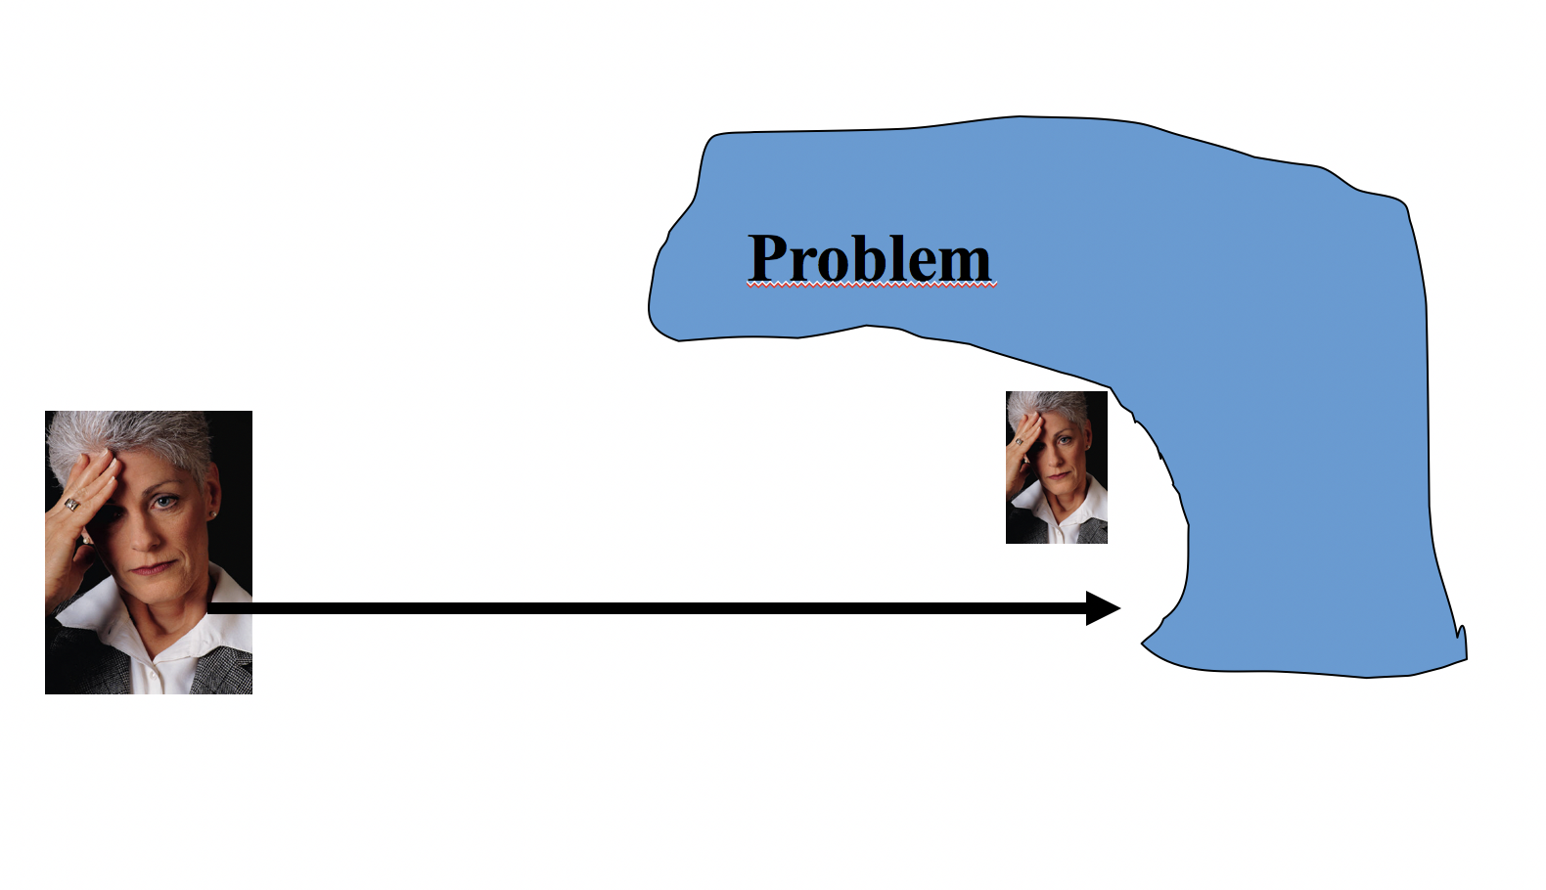
We have seen in the above-mentioned, that you should take some distance from your problem and have to view it from another perspective. That other perspective for a Christian is the perspective of Christ. In Col.3:1-3 it is said: “Therefore if you have been raised up with Christ, keep seeking the things above, where Christ is, seated at the right hand of God. Set your mind on the things above, not on the things that are on earth. For you have died and your life is hidden with Christ in God.” If we would be able to view the problem from the perspective of Christ, it becomes easier for us to deal with it. We then come within His possibilities to solve the problem or to empower ourselves to be able to deal with it properly.
In the picture Christ is presented as the good Shepherd who takes the stray sheep on his shoulders and as the Father who takes his child in his arms. Yes, you may say that it is said easily, but the practice is more problematic. That’s right; it is therefore a skill which you must learn.
In the second picture you see that we must learn to go to Christ via the diagonal. In order to learn that properly, you should do two things. First of all, you should consciously decide that you will entrust your problem to God (Psa.37:5) “Commit your way to the Lord, trust also in Him, and He will do it.”
At the same time you should practice confidence. In Psa.125:1 it is written: “Those who trust in the Lord are as Mount Zion, which cannot be moved but abides forever.” This confidence is beside the action of the will also a learning process; we must learn to trust Him in every aspect, which does not come naturally. We have seen that the Bible sees our new life as a tree, a unity of life with Christ. When this tree is nourished properly, it will ultimately bear fruit. Galations 5:22 mentions that particular fruit, which consists of self-control, patience, love, but also of faithfulness (confidence) (the Greek word is pistis).

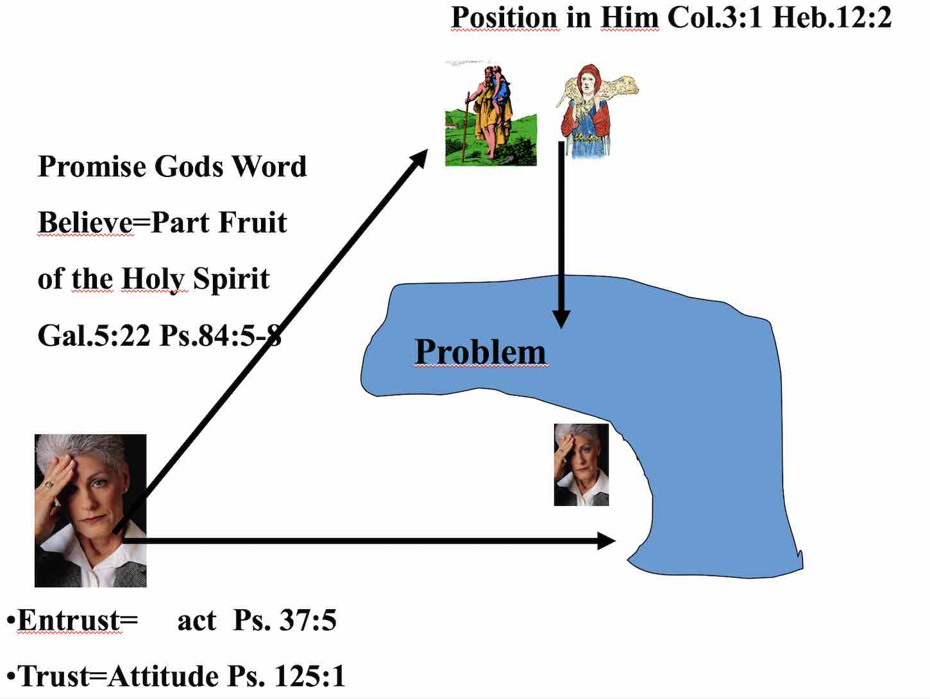

When we practice to approach our problems by taking the route through Christ, we will gain more confidence as fruit. A confidence which go beyond our natural thinking and puts us within the possibilities of God. In Psalm 84:4-7 it is also expressed very beautifully: “How blessed are those who dwell in Your house! They are ever praising You. (Gratitude is another skill of the brain.) How blessed is the man whose strength is in You, in whose heart are the highways to Zion! Passing through the valley of Baca they make it a spring; The early rain also covers it with blessings. They go from strength to strength, every one of them appears before God in Zion.”
It says: in whose heart are the highways to Zion. The way is the heart of the spirit of man to the heart or the Spirit of God. That way must become a highway. In the beginning it is a difficult way. Compare it to a forest path which is full of shrubs; only when people walk on it very often, it becomes more and more accessible. That’s how it also works with walking the way to the heart of God; only when we have the skill to walk that way often, we are able to view our problems and circumstances from the heart of Jesus, to look with our hearts. From that position the Lord can make it clear to us whether we should act or not and how to. (Compare the way in which Elisha acted.) Sometimes it leads to a definite wondrous solution, sometimes God empowers us to bear the thorn in the flesh.

The consequences of learning this skill
We realize that we often see only a part of the reality of a problem. We ask God more often what to do in a specific situation. Lord what can I do in this situation with that nasty colleague, neighbor etcetera? We become aware that we are in some situations with a certain purpose. Lord, would help me to view my friend, child, or acquaintance with your eyes? We often find comfort and experience rest in difficult moments on a day. Because we look with the heart of Jesus, we respond the way Jesus would, and are also able to respond with a full self-control, which is actually the fruit of His Spirit, His Heart.
When I remember the moments that God spoke to me in the past, it is also easier to make contact in the here and now by prayer and or thanksgiving.
This is also possible during the day, at our work place, in the street, at home in church. Sometimes God gives wise words which are just needed in a certain situation. Sometimes God shows His presence by humor. I will given an example from my own experience. The name of my father in law is Nagtegaal (which is nightingale in English). A pastor, due to whom my wife and I came to faith, was working in his garden one day. He used to speak to God and he said to God: “I would love to see a nightingale right now!” At that very moment the telephone rang and my father in law who was at the other side of the phone, said: Yes, this is Nagtegaal speaking!” That’s where our conversion story started! God can encourage us by the beauty of nature where we can become aware of His Creator- power. Because of the love that we have for our children, we can become aware of God’s endless love for us, as His children. In Mat17: 2-7 Peter, James and John were walking with Jesus when He suddenly was transfigured before them. His face shone like the sun and His garments became as white as light. Suddenly Moses and Elijah appeared to them. In verse 7 it is written that Jesus came to them and touched them and said, “Get up, and do not be afraid.” And lifting up their eyes, they saw no one except Jesus Himself alone.
A lot more happened in reality and Jesus showed it to His disciples. They tasted something of the heavenly reality, while they were still in their earthly body. Maybe our daily experiences are not always comparable with these pinnacle experiences. But if we are actively in contact with Jesus on our way, He will show us more and more what He sees. We will see with the heart of Jesus (Psa 36:9)

Gerard Feller, November 2016

Translated by Ursula Moestapa

Notes
1) In https://stichting-promise.nl/jim-wilder/onvolwassen-leiderschap.htm you can read what happens when someone with a weak Christian identity leads a congregation.
2) Dr. E. James Wilder, Met vreugde man zijn: groeien naar volwassenheid, 448 p., genaaid gebrocheerd. ISBN: 9789079011018. Verkoopprijs: € 24,95.
3) https://stichting-promise.nl/pastorale-onderwerpen/vreugdevolle-identiteit-in-het-aangezicht-van-god.htm
4) http://www.12accede.nl/Negentien-vaardigheden-om-te-floreren_JimWilder.pdf
5) Chris M. Coursey, Transforming Fellowship, 19 Brain skills that build joyfull community 267 blz. isbn 978-1-935629-22-4 uitgegeven door Shepherd’s House inc. verkrijgbaar via de webshop van Promise
6) https://stichting-promise.nl/jim-wilder/4-hersensynchronisatie.htm
7) DanielJ. Siegel Mindsight, The psychology of the new consciousness. 2010 Uitgeverij Spectrum isbn 9789049103903, 352 pagina’s €16,30 The author is a well-known professor of applied psychiatry at the University of California and co managing director at the Mindfull Awareness Research Center. He has already written more about interpersonal neurobiology and psychology.
8 http://www.topics.nl/misschien-leven-we-wel-echt-in-de-matrix-a3418875demorgen/?context=playlist/m-beste-van-de-wetenschap-58ba46/?utm

