The importance of developing relational brain skills

By Gerard Feller

Introduction
In recent decades, the knowledge about the functioning of the brains has increased. Due to the development of all kinds of scans, there is more and more knowledge available about neurophysiology, the functioning of the brain. Many studies are focused on the integration of the left and right part of the brain. The importance of thinking as a dominant function of the left part of the brain is known to many people.
It is less known that the development of the underlying relational skills of the right part of the brain are decisive for our way of thinking and give shape to our identity and emotional skills.
Much of what we call unconscious, are acquired skills, which are activated much quicker than the conscious thinking in the brain.
It is striking to note that many conditions for a healthy development are also biblically important values.
For example a good joyful individual and group identity, a capability to come to rest in difficult circumstances, self-control, solidarity and dealing well with boundaries.
In the past, a lot of emphasis was placed on the development of thinking in various Christian circles, without addressing the indispensable relational skills of the right part of the brain. The Life Model which has been regularly published about in this magazine, fills this gap.
Nineteen relational brain skills which are essential for (spiritual) maturity, have been formulated.
God has also created man in relationships, with Himself, with other men, in our individual environment, but also with relations in the man himself. Please note that it is in no way the intention to switch off our thinking, which would be very unbiblical, but on the contrary, to satisfy the mind by a sound development of characteristics and skills of the right part of the brain.
In this article I do not want to highlight these skills, but more to underline its importance.
(In the previous magazine, I have highlighted a skill which I called: To look with your heart, the heart of Jesus. We hope to identify more skills in the future and to describe them)

The research of António Rosa Damásio
António Rosa Damásio is a Portugese neurologist and writer who has been living the United States for decades. He is best known for his book Descartes' Error: Emotion, Reason, and the Human Brain.
He describes in this book the biological basis of the functioning of the brain. He examined, for instance, people who after a brain damage were showing strong character changes.
He discovered that especially the changes in the right part of the brain were the cause of it.
People seemed to be more focused on themselves and were functioning less relational.
Only in the nineties of the past century, it became possible to do more research by the means of brain scans. The functioning of the brains of living people could be examined, for instance by an increased blood circulation as a signal of activity of a certain part of the brain.
Especially the center, which is responsible for the character and for the standards and values, had been examined.
This is the same center which is responsible for the control of emotions and dealing with relationships. The functioning of this prefrontal cortex is decisive for our identity and controls all our possible options, often before we even make the choices consciously. We must be careful to label the brain as the only source of our identity, but it certainly determines the boundaries of the functioning of our identity for a greater part.
We profess our identity as Christians from our faith, but we cannot deny that the limitations of our identity play a major role in the brains.
We can for example be very fearful, in spite of the fact that we know by faith that we don’t have to.
Only people who have never seen what the consequences are of damaged brains, have doubts about this assumption.
The theory of Dr. Allan Shore
Dr. Shore from the university of Los Angeles has studied the results of scientific research about the brains, for more than 17 years. He has made a major contribution to research into the development of our identity.
He described for example the importance of the skills in which especially the right part of the brain is involved. He discovered that identity and character are relationally determined, in particular by people who are happy to be with us.
Relational skills are copied in a joyful context, as it were, from an older brain (the educator) into the young brain (the growing child).
This process is a two-way process, which is a communication in the brains which runs faster than our conscious thoughts and which we cannot control consciously in a direct way. This is called the ‘fast circuit’ in our brains.
The relational skills are developed here in a good or bad way.
The relational identity is the center of who we are and has to be updated constantly to the extent in which we learn how to grow in developing these relational skills with joy.

Brain skills are often synonymous to biblical values
The development of the identity in a joyful community is one of the core values of the Bible.
The Christian faith is not only an intellectual adoption of a number of dogmas, but certainly also a relationship with the living God and relationships in a loving, protected community of believers in which joy, peace (shalom) and merciful, gentle relationships are central.
Christians are not only considered to form joyful communities, but also to have a loving, protective influence on their (unbelieving) environment.
Dr. Shore has published books that gave neuroscientific basis for core values of the Bible.
Just like character and skills have to be shaped in a development of faith, the brain also has to, not only in the intellectual area but especially on ‘the fast circuit’ of our brain.

The fast circuit
We have the propensity to call everything ‘automatic’ when it goes faster than our consciousness. But that doesn’t mean that this ‘automatism’ has not been acquired within our brain. Because it goes that fast, we do not consciously remember that we have first acquired it. These automatically acquired processes in our brains, are for example: our identity, motivation, emotional control, our capacity to focus on something, our conscience and valuation system. These skills, which particularly have to do with our identity and emotional intelligence, show a much faster brain activity than our conscious thinking.
We often assume that others have the same skills like we do, but that varies a lot in practice.
The conscious thinking, which is especially located in the left part of the brain, is called the ‘slow circuit’.
Slow is only relative, for it is being updated five times per second.
The outer part of the brains is covered with the so-called gray matter, the deeper inner part is incorporated with the white matter.
The identity process for example, namely: that we know who we are and how we respond to certain situations, starts to go faster in the brain, specifically six times per second. The speed in the ‘gray matter’ of our brains is very flexible and adjusts to a new reality.
However, when something has to immerse deeply into the brain, the brain will create certain habits (skills), a ‘typical’ response in familiar situations.
These immersed habits have to be acquired at least during one month, so that the brain can embed these nerve patterns and responses into the ‘white matter’’.
Once the habit or skill has incorporated well in the white matter, it goes even two hundred times (!) faster than in the gray matter.
Because the average person in the Netherlands watches television more than three hours a day and on top of that is confronted for four hours a day with a textually based communication device such as an IPad, a personal computer, a cell phone etc., it is seemingly that the communication skills of the right part of his brain will disappear faster than the rain forests in the world.
If we understand the skills and habits of the white matter, we know that they run much faster than our consciousness.
Well imbedded, sustainable habits in the fast circuit enable us to return fast from stress to joy and peace (restoration of relationships), to quickly remember who we are after each peak of emotion in a crisis and how to respond in such situations out of a better self-control.
In an ill-trained skill circuit, we will fight with all of these skills and make a major appeal upon our (slow) conscious thinking and often remain entangled in a thinking in circles which ultimately often results in uncontrolled emotions and behavior.
Therefore, there are two different systems which we probably simplistically call the left and right brain. Simplistic because the integration of those systems normally are related to one another in a very special way. The system which is dominating in the left side is the ‘slow circuit’. This makes conscious thoughts possible. It is extremely suitable for management. Its most important task is result-oriented; it provides in explanations and solutions for the problems with which we are being confronted.
So, in addition, there is the ‘fast circuit’ which particularly takes place unconsciously and works faster than our consciousness. Its most important task is relation-oriented and determines our identity and the control of our emotions for the greater part, as it was said earlier. The faster part does not listen to words but observes what people do. This explains also that we sometimes feel a presence before we think of a person.

Slow circuit | Fast circuit
Management system | Master system
‘Slow’ processor 5 Hz. | ‘Fast’ processor 6 Hz
Active in a conscious condition | Superconscious and subconscious
Left brain part is  dominant | Right brain part is  dominant
Follows the master systeem | Determines individual identity
Creates strategies | Determines group identity
Solves problems | Regulates individual motivation
Deals with long-term planning | Regulates group motivation
Optimizes results | Optimizes involvement

An example of different brain dominance
Marcus Warner, the president of the ‘Deeper Walk International’ gives an example of a different domination system.
He was talking with some pastors who were complaining about the young people leaving the church. They discussed how they could make the church attractive again to the youth. Due to this way of management thinking, the leaders got entangled in the ‘slow circuit’. The result was that the solutions to get the youth back to church again were continuously focused on programs. They were playing around with a dominant thinking of the left brain which was result-oriented and only focused on problem solution. Because Marcus was more oriented on his fast right brain, he noticed that their problem had little to do with programming. The solution was more to be found in the area of relationships. There were just a few youngsters in the church who had a relationship with an older person. Adults and older people hardly worked on a relationship with the youth. The result is that the youngsters felt isolated and not connected with the church. If people want to keep the youngsters in the church, they need to make sure that they feel involved, appreciated and loved. It’s not so important what kind of music group is playing and what the program of the service looks like. Marcus dealt with it carefully. He did not upset or frighten the pastors by saying that if they do not want to change their way of approach, they will lose the youth forever. But he began to make them aware of the relational involvement. He also used curiosity as an important tool and asked them: “Have you ever addressed this issue also from the (group) identity of the church and the fact that they feel at home and appreciated instead of planning new programs?”
Finally – to begin with – the relationship between the pastors had been already more involved in this conversation. For the sake of clarity, his point was not to put off the thinking, but to come from a skillful ‘fast circuit’ into a more integrated thinking whereby the left and the right brain were functioning in an optimal way.
Therapy and the ‘fast circuit’
Most of the therapies just spend little attention to skills training and therefore apply the same method to everyone.
The greater part of the relational skills of the brain are a part of the affect regulation: the process of the reality and identity building, which is the basis on which higher skills are built.
When elementary relational functions such as interactive emotional regulation are missing or disturbed, the higher brain functions will not function well or will be stressed. We can for example conclude that one functions quite well when he or she is alone, but that in the presence of others, relationships often come under pressure and that the emotional regulation: relaxing in a relationship, fails over and over again.
When we are well aware of it, we should realize that an important condition for therapists in order to do their job well, is that they master the complete list of relational skills.
The education of therapists will have to be focused on identifying weak spots in this area and learning how one should acquire the missing skills and pass them on to others.
Successful therapy is based on knowing relational skills that are necessary for the people-to-people and brain-to-brain communication.
Clinicians should be educated to change the structure, chemistry and functional configuration of the brain, in order to develop new skills and to prioritize it.
In order to produce relational skills of the brain and to communicate, a mutual consciousness of trained and untrained brains must be created.
A ‘right-brain-to-right-brain communication uses non-verbal signals which work faster than the conscious thinking.
This two-way consciousness is called ‘intersubjectivity’ in the psychoanalytical literature.
In the work of Daniel Siegel MD it is called ‘mind sight’.
The brain systems that are necessary for this communication are called ‘relational circuits’ (RCs) by Karl Lehman.
He has discovered a simple way how to know whether those circuits are active at a certain moment.
In order for one to know how to get access to it and remain there, he will have to work on this communication from moment to moment by developing empathy, conditional communication, motivation, interpersonal awareness, emotional regulation and the practice of relational therapies and on the solving of traumas.
What kind of brain skills are we talking about now?
A complete list of the 19 skills is to be found on the website of André Roosma: http://www.12accede.nl/Negentien-vaardigheden-om-te-floreren_JimWilder.pdf
For example the second skill which we need, is the capability to come to rest in relation toward ourselves and towards others.
And in order to synchronize our emotional state with others, and the skill to come to rest quickly in a state of great excitement and not to be overwhelmed by others.
The latter skill trains the nervus vagus and is necessary to prevent domestic violence, child abuse and violent sex.

Healthy leadership and the ‘fast circuit’
‘RARE leadership, 4 uncommon habits for increasing Trust, Joy and Engagement in the People you lead‘ is an interesting book, written by Dr. Jim Wilder and Dr. Marcus Warner in 2016. RARE is an acronym for 4 important brain skills of successful leaders. The R stands for Remain Relational (Stay in a relational mode), A stands for Act like Yourself (Remain faithful to your identity), R stands for Return to joy (when you’re emotionally triggered, you learn to come to rest and peace quickly), E stands for Endure hardships well (Learn to face difficulties).
RARE leaders teach that relationships are more important than problems, and diminish the chance of a permanent split. They inspire followers to recover from strong negative emotions and they protect the unity in their teams by reminding the people who are overwhelmed by strong negative emotions, of their identity. They educate adult followers in the process of the care and appreciation of their relational skills.
Leaders can pass relational skills on to others, only as they themselves do have them, otherwise they will function out of fear and stagnate the growth of their followers.
Good leaders acknowledge their own limitations and do their utmost to work on themselves and others within the time that is available to them.
Giving priority to joyful skills for a person also means emphasizing his own growth as an indispensable part of a successful leadership.
Studies have shown that effective leaders have a joyful, relational and creative attitude, a lot more than leaders who are only problem-oriented, fearful and strict. That means that their relational brain is well-trained and skillful. Good information, a good education and charisma alone, do not make a person directly a good leader. Relational leaders with emotional intelligence often transmit a successful work.
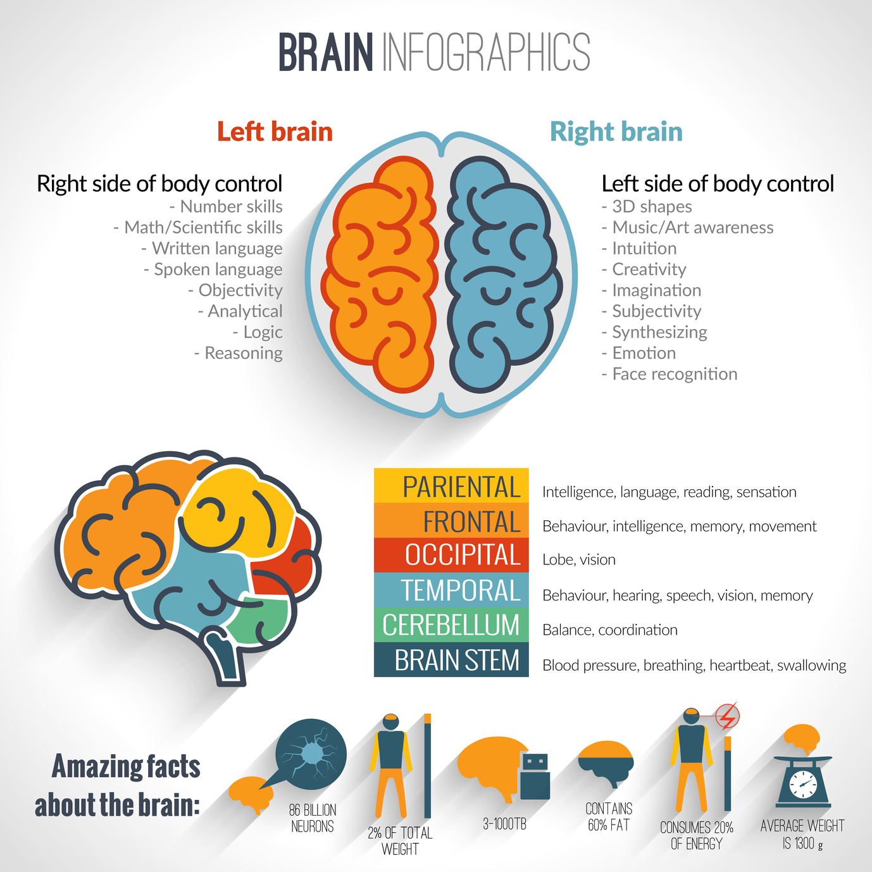
The guidance of God
Christians who are used to consider the guidance of God only from the slow conscious circuit, will have difficulty in allowing God into the fast circuit of the brain where they cannot follow God in all of His actions continuously in a conscious way.
Their main objection is that they consider allowing God into the total brain as a charismatic gift or an unnecessary new addition in the Bible (the speaking of God).
Dr. Dallas Willard, writer of the book ‘In search of Guidance’ (‘In hearing God’ was added later in a more recent version), noticed that God guides the thoughts of His children in variously special and active ways.
Knowing God’s voice and being guided by the Holy Spirit is the inheritance of God’s people. A lot more than being afraid when we search God’s guidance, is that we should expect it from our knowledge of the Bible. Of course we are to test everything, but we should also dare to expect that God really guides us.
In Jn10:27 it is written: “My sheep hear my voice. I know them, and they follow Me”. The Greek Word for to know here is ginosko (NT1097). Ginosko is a personally relational knowing, it stands for knowing, recognizing, understanding or ‘fully understand’. It is not only an exchange of information but more an experience of knowing which comes forth from a relational connection and interaction.
The word ginosko is also used in Mk 5:29 where the woman with the blood issue ‘noticed’ (felt) from her body that she had been permanently healed.
Dallas Willard explained that the Life Model is the best method wherein God is central and leads to a restoration of many damaged churches. The most important condition according to Dallas Willard, is love for people. In a loving, compassionate and merciful church, not only educated leaders with all kinds of titles is an important condition, but leaders who are spiritually mature and who are actively and consciously focused on God’s guidance. Maturity is nothing more than a well working system of relational skills out of which God’s guidance is searched continuously.
In the Life Model this is called ‘Immanuel Lifestyle’. The three main focus areas of the Life Model are:
  - The development of a multigenerational individual with a group identity. Being involved with one another, concerning different age groups.
  - An Immanuel Lifestyle, in which our relationships are brought in agreement with Him by the interactive the presence of God in the now.
  - The replacement and development of relational skills of brain functions when they are missing with individuals, communities and cultures.
Relational characteristics in the Bible.
When you examine the word koinonia (friendship-brotherhood) in the Bible, it is always embedded in a relational and joyful, gentle and merciful engagement.
The friendship in a koinonia fellowship is a permanent engagement.
This covenant goes even further than ‘till death do us part’ and changes us continuously into ‘we’ (in Christ) instead of ‘I’.
Read 1 Cor.1: 8-10: “Who will also confirm you to the end, blameless in the day of our Lord Jesus Christ. God is faithful, through whom you were called into fellowship with His Son, Jesus Christ our Lord. Now I exhort you, brethren, by the name of our Lord Jesus Christ, that you all agree and that there be no divisions among you, but that you be made complete in the same mind and in the same judgment.”

In the koinonia fellowship we learn to have better relationships with the help of the Holy Spirit (2 Cor. 13:13). Our service and ministries are established by koinonia (Gal.2:9). They are focused on the needs of others and exhorts to bear one another’s burdens (Gal.6:2). Sometimes also with sharing together in the suffering (Phil.3:10). John goes even a step further and calls the sharing and teaching of character building in relational fellowship, a sign that our sins are forgiven: “But if we walk in the Light as He Himself is in the Light, we have fellowship with one another, and the blood of Jesus His Son cleanses us from all sin.” (1Jn 1:7).

Relational right-brain skills of Jesus as an ideal example.
(From: The emotional perfection of Jesus, by Gerard Feller)
In all of the gospels we become impressed by the relation of Jesus to God. He lived in partnership with God and ‘experienced’ Him, and that was enough. His knowing about God resulted from His relationship with God. When He talked about God, He talked in the full awareness of God’s presence. He knew God’s Word like no one else does; His left and right brain must have been perfectly synchronized. It is not true that He had to practice a heroic faith, in spite of all contradiction which He had to face. No, God was not a dubious matter to Jesus. He was continuously aware of the presence of God.
As Lehman would say: “His relational circuit was always active, even up until the cross!” John calls the acts of Jesus: signs, which must have been symbols of His spiritual life (Jn 2:11; 20:30).
These signs were not sorceries, but always served spiritual and moral purposes, and His love. This serving love was controlling His acts. They showed perfectly relational skills.
Take for example the touching of the sick. In those days a deaf-mute was more an object of dismay than of compassion. Jesus approached people with a loving heart and a gentle touch (Mk 7:33).
Jesus’s meaningful touching of the sick, particularly the blind and the mute, was full of love.
How much of the loving warmth must His hands have radiated to the dead little daughter that was laying on the bed? (Mk 5:41). His body language was not contrived, but fully in line with His sinless soul.
The judicial workers arresting Him drew back and fell to the ground because of His ‘body language’ of word, look and appearance (Jn 18:6). He tested the numb conscience of the Scribes and Pharisees by catching their eyes at the healing of the man with the withered hand (Lk 6:10).
How angry He was then, but later His anger made room for deep sorrow (Mk 3:5). In Mk 10:23 His eyes were in cooperation with His teaching to the apostles on how to be aware of the dangers of great wealth. Thereafter in verse 27 He comforted them with a glance to emphasize that with God nothing is impossible.
Jesus knew the power of His eyes.
In the night of the betrayal, Jesus led Peter through to the redemptive exit of deep repentance by His look (Lk 22:61). With a special focus he observed the natural phenomena.
He saw the sparrows on the roof (Mat. 10:29), the flowers in the garden (Mat. 6:28), the tailor patching old garments (Mat.9:16), the children calling to one another (Lk 7:32). Jesus used a perfect metaphor, which was in line with Someone who had a perfect body language.
He allowed someone to hand Him a coin (Mat. 22:19); He set a child before a crowd (Mat. 18:2); He pointed with His finger at the lilies and the birds in the field (Matt. 6:26,28), at the fishermen’s net on the sea shore (Mat. 13:47) and at the Sower and the land (Mat. 13:3).
He educated the people with illustrations by using parables. The apostles had to learn to be the least, and by way of illustration He took a cotton towel and a water basin and washed their feet (Jn 13:14). They had to know that He was going to die. He broke the bread which was a symbol of His body, in their sight (Matt. 26:26). They had to know that He had to die for them and therefore He offered them the broken bread, so that they could eat it.
They had to know where He was going and therefore He ascended to heaven in their sight (Acts 1:9). Jesus is both in heaven and in the believers, omnipresent by His Spirit.
The ‘radiance’ of Jesus had always been a radiance of compassion, love and mercy. His relational mode was always active. His gentleness and kindness caused the parents to bring their children to Him (Mat. 18:12).
His sunny warm-heartedness had always led Him in all of His ways, and although Judas was going to betray Him with a kiss, He blamed Simon the Pharisee for not giving Him a kiss (Lk 7:45).
The old oriental tradition of attaching a kiss to a greeting, became a Christian habit (Rom. 16:16, 1 Cor. 16:20, 1 Pet. 5:14).

Jesus always remained to be faithful to His identity in very strong emotions!
The control center of our brain (prefrontal cortex) aims to remind us of how to respond like ourselves in all circumstances.
In other words, it is a matter of a good outcome of the synchronization process between the inner and outer side, whatever happens.
As soon as something happens, emotions arise such as joy, sorrow, fright, anger, shame, disgust, despair and humiliation.
Sometimes they happen from the inside and sometimes they are also aroused by others around us.
When our control center is undeveloped and unorganized, when we have not acquired relational skills, the synchronization process will not develop well, which may cause us to lose control over our lives due to these strong emotions.
We can be overruled by strong emotions and therefore react differently than we would want to, according to our identity. We would for example respond aggressively to aggression. With Jesus this was absolutely not the case!
Even in His strongest pains and emotions on the cross, He remained to be Himself. He did not get traumatized, He did not react aggressively to aggression. On the contrary, He cried to His Father to forgive them! To be able to do this, a perfect spiritual life and a perfect control of all of the earlier mentioned 19 skills are necessary.
© Gerard Feller (mei 2017)

Literatuur:
- Chris M. Coursey: Transforming Fellowship, 19 brain skills that build joyful community. Shepherd’s House Inc. P.O. Box 2376 East Peoria IL61611, 2016 (.ISBN 978-1-935629-21-4) (ook verkrijgbaar in de webshop van Stichting Promise)
- Marcus Warner en Jim Wilder: Rare leadership, 4 uncommon Habits for increasing Trust, Joy, and Engagement in the people you lead. Moody Publishers, Chicago 2016 (ook verkrijgbaar in de webshop van Stichting Promise)
- In de transformatiezone. Archippus Boeken, Enschede 2016 (.ISBN 978-90-79011-00-1)
- http://www.12accede.nl/Negentien-vaardigheden-om-te-floreren_JimWilder.pdf
- Gerard Feller: Het volmaakte emotionele leven van Jezus. https://stichting-promise.nl/bijbelstudies-bemoedigend/het-volmaakte-emotionele-leven-van-jezus.htm
- Zie verder de vele artikelen van dr. Jim Wilder op de website van Stichting Promise. https://stichting-promise.nl/jim-wilder
- Lehman, Karl (2011). The Processing Pathway for Painful Experiences (De weg van verwerking voor pijnlijke ervaringen). www.kclehman.com/download.php?doc=131
- Lehman, Karl (2011). Outsmarting Yourself (Jezelf te slim af zijn). Libertyville: The Joy Books (ISBN 978-0-9834546-9-4) https://stichting-promise.nl/jim-wilder/tien-belangrijke-vaardigheden-van-therapeuten-dl-1-en-2.htm

