Stressmanagement (English)

By Gerard Feller

In our hectic society many people feel that the pressure of work, family and social expectations are getting heavier and heavier. This Biblical article about ‘stress management’ provides guidance on the issue, where it comes from, how it affects you and how to manage it better. This timely and far-reaching topic explains how stress manifests itself; from achievement drive to mental exhaustion. It also emphasizes the crucial role of faith and the restoration. As the author Gerard Feller explains, stress is, more often than we think, an issue of spirit, soul and body, and it calls for an ‘all-around’ approach. Besides prayer and prayer support, the article pleads for the testing against Biblical values in regular treatment methods. In this way a pastoral approach is created that is both practical and profound. Discover in this article inspiring guidance not only to fight stress, but to really deal with it – supported by your faith in the power of God.

Inhoud verberg
.Definition
Sick or not sick
Backgrounds of stress
Biology of stress
Homeostasis
Other chronic consequences
Through what lens does one view stress?
Stress and spiritual life
God is faithful
Tips
Looking at problems from the relationship with Jesus
Literature:

Definition
Since ancient memory there has been stress. It is not easy to find a definition of stress that is acceptable for everyone. The idea is interpreted differently by different groups of men.
Physicians, psychologists, business men and ‘laymen’ use the term in their own way. Physicians speak in terms of physiological mechanisms, psychologists speak in terms of behavioral changes and businessmen speak in terms of ‘organizational challenges’. Laymen speak in terms of domestic problems and Christians speak in terms of spiritual battle.
In general, stress could be defined in such a way that when the physical, spiritual or psychological burden is heavier than the burden capacity, there is stress. Beware, it is not always illness-causing of performance reducing. Man has learned to adjust psychologically, biologically and spiritually to stress. Then there is a question of an adaptation process which implies that strengths are applied at different levels to cope with the stressor, and to overcome it.
As it has been said, there are stressors of different levels: physical, psychological, spiritual, biological, and many more. With a cold stressor e.g., when one is exposed for a long time to cold temperatures (physical stress), the body responds by activating the neighboring mechanisms by for example adapting itself with shivers, and in that way the stressor can ultimately overcome the cold trigger and will on balance come out stronger. The person is from now on more resistant to cold stimuli.
This adjustment or adaptation capacity applies to all levels. Seleije (1976) calls it eustress or positive stress. If the interplay of the body, psyche or spirit of a man cannot overcome the stress stimuli, it can lead to damage, illness, or reduced resistance. This is called distress (negatively reactive stress). Of course this applies for each person to a different degree, among other things, depending on many factors.

Sick or not sick
Just like in the computer world, there is a God given ‘hardware’ (structure + influences) in the functioning of man. It works in combination with the program that the individual him/herself chooses. These are the personal will decisions of man. Just as in the IT-business, we became ‘failure sensitive’ (vulnerable) and came from outside man unto man due to the events occurred in Genesis 2. The size (disposition) of the vulnerability and sensibility is also due to the ‘hardware’ of man, and depending on different factors that belong to the essence of man. In the Zubin schedule they are called the pre-dispositional factors (predestined factors). The genetic propensity: there are people with great resilience, in contrast to people who live ‘inside out’ in terms of tolerance capacity who have no protection whatsoever to the outside world. Furthermore, it becomes increasingly apparent that there are structural organic brain function disorders. Think of epileptic patients, ADHD, hyper kinetic and development disorders based on the alcohol syndrome of the mother. Of course, one of the most important pre-dispositional factors is the formation of the overall picture of the environment, upbringing, education and experience. Especially negative experiences in general have a greater impact than the positive events because they have a direct influence on the stimulus level of the sensitivity mechanism. Furthermore, the pre-morbid factors play a role. These are the negative experiences suffered during illnesses. For example the groaning of people with negative psychological disorders. But also psychological wounds caused by long-term hospitalizations.
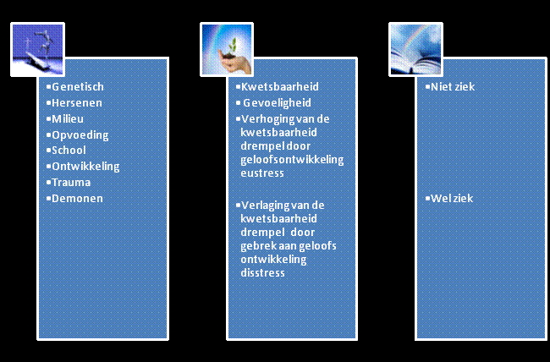
Dealing with all kinds of limitations both psychologically and spiritually; all the victories and losses included. In the above adjusted schedule by Zubin, you see a limited overview on how among others stress can lead to illness or not.

Backgrounds of stress
We have already been introduced to the idea of stress. We have mainly studied the physical consequences on short and long term in the body. Stress was, as we have seen, an adaptation attempt of the body to a stimulus that was wrong in type, volume and size. Now what are situations and circumstances that usually cause stress in many people? There has been a lot of research on that. Most researchers have come to similar conclusions. We shall list the most common causes of stress in order of importance.
1. In the first place spiritual conflicts; There is no living open relationship with Christ; we shall elaborate on this later.
2. Death of a husband or wife, or a divorce;
3. Personal injury
4. Retirement
5. Sexual problems, a new family member, changes at work
6. Changes in working hours
7. Minor law violations
8. Holidays/financial problems
9. Extra responsibilities, school stress.
Of course it is true that everybody suffers from a stress stimulus. Usually there are more factors. Not all stress stimuli are illness-causing. People even need a certain degree of stress in order to be stimulated for work performances. In many research where test persons in whom stress factors were eliminated as much as possible, these persons, after some days to some weeks became alienated, distant from humans and in the long run their behavior became seriously deranged. Not every person responds the same way to stress stimuli.
One can e.g. due to a certain stupidity or misunderstanding be protected against the stress of insults. There are people in whom the stress arrows only very rarely penetrate through their great resilience. There are also people who due to the fact that their spiritual and/or psychological balance are too stable to be affected by normal stressors. Of course it is also important in which period of time and in which situation of the person the stress arrows take effect, and whether they cause illness in him/her. We are dealing here with the so-called frustration tolerance.
We shall try to explain one thing and another in a diagram. As we have said, we need stress stimuli to achieve a performance. In the diagram you see horizontally drawn the climbing stress stimuli. At point zero there is no stress and at the point on the right you see a maximum number of stress stimuli.

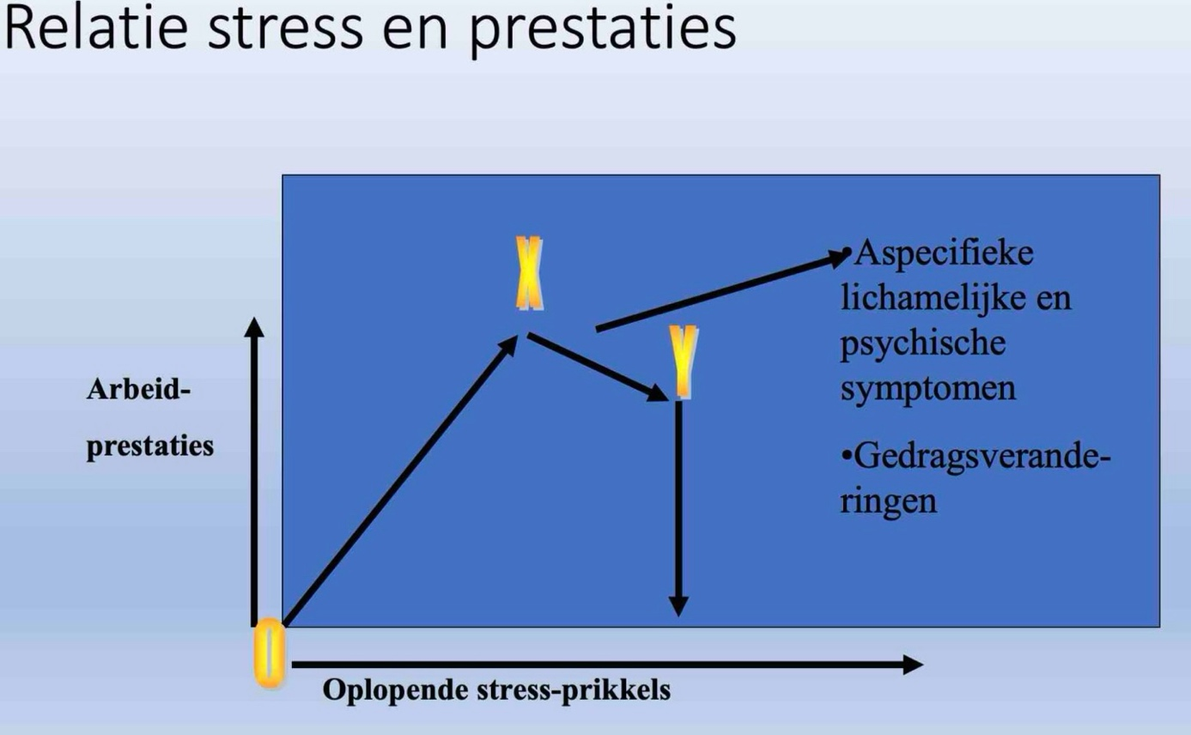
The vertical line indicates the work performances. At point zero no performances and at point B the maximum. In the 1st phase of the diagram, we see that in case of a healthy dose of stress stimuli, the performances strongly increase. Up to point X; hereafter, more stress stimuli do not cause more work performances. On the contrary, the work performances become less, whereas the stress stimuli increase. At point K it is even so that if more stress stimuli are allowed, the person collapses. He/she is then overstressed as it is called or more playfully said: “He’s/she’s about to lose it”.
At a healthy dose of tension, one feels comfortable, takes time for relaxation now and then or for a walk. They don’t feel guilty when they don’t work. They can also let others do something. But if they pass point X on the diagram, then this becomes less and less. They start to sleep less and less and they start living more irregularly. They claim to be healthy, but other people in their environment often assess it differently. They no longer see the need of remaining fit. The fatigue affects among others their assessment. There’s no self-criticism. A well-known example is an exhausted stay-at-home mom that suffers from the so-called martyr complex. An increase of too many stimuli leads to less performances.
So will such a stay-at-home mom ask for more and more tension stimuli in her life. She can no longer say no. Besides bringing the kids to school and picking them up from school four times a day and her domestic duties, she also gives assistance at the reading class in school. In addition, she tries to achieve her maternity high school diploma, and if she is asked to assist as a crossing guard, she neither says no. Her life becomes a continuous race to the next stress stimulus and in the end the stress could make her sick, as we have seen earlier. Sufferers from stress allow stress more and more in their lives.
An important symptom is that people in such a situation become more and more preoccupied with futilities and they ignore the really important causes of stress. They can make a tremendous fuss about a red traffic light or the dog of the neighbors and pay extensive attention to it, while they do nothing about the real cause of stress, e.g. the bad relationship with their spouse. They start to eat, drink or smoke more, or on the contrary, their appetite disappears completely. They start to skip meals. The more serious the situation, the less likely the chance that a caregiver is called upon.
Due to the changed life patterns, the biological clock in the body gets out of balance and they do not come to the necessary rest. The sensitivity of the individual man for stress is very different, as it has already been noticed. Besides the psychological/spiritual/physical health of man, there are also certain professions that are highly stressful. For example general practitioners that have to be available for their patients day and night. They are no specialists, and often the sense arises in them that they haven’t got the time to read their professional literature. They have no time for anything. Also pilots who constantly exceed their biological clock are very stress sensitive. Just like the traffic controller who is under pressure from timetables and dependent on uncertain factors.
Consider also a bus driver who has no time to stretch his legs and the waitress who gets lung cancer because she always has to work in smoky rooms. So there are of course still countless examples. Today there is an increasing pressure on employees to achieve performances. People get promoted with a job too high and have to walk on their toes to keep everything running and have no longer time for their family. Children are often overburdened with tests, trials and exams. People are increasingly engulfed by the media with misery and terrifying news from all over the world. Urban inhabitants in apartment buildings no longer see vegetation and they often get apartment-building- neurosis.
And what about the increasing noise and sound pollution, environmental pollution and the rapidly worsening moral decay? Also aging and its resulting problems are stress-inducing factors for more and more people. More and more people are leaving the safe and familiar standards from God’s Word. People feel that values and foundations are slipping out from under them. They are being transformed into so-called free emancipated people by all kinds of innovators in media, health-care and social coaching. Free means: without the blessing presence of God. They allow themselves, whether consciously or unconsciously, to be manipulated to another way of thinking and living. Unfortunately, one of the focal points of this movement, the modern theology that often negate and relativize God’s Word, but also in arts, literature, movies, this unwholesome change is gaining ground and is in that way constantly fueling a selfish, heartless and stressful world.
Not only the environment of man is full of attackers, but certainly also his inner-being. The Bible calls it the old heart, out of which no good comes and which makes people tired, sick and burdened. How many people aren’t there with personal problems? Relational problems in families, at work or in their circle of acquaintances? How many people are not oppressed by the behavior of others and therefore end up in almost hopeless situations? How many people are not suffering from their personal sins, from wrong thoughts and actions of which they are the primary victims themselves? How many people are not ingrained and locked up in a habit and behavioral experience that frightens and limits people? The number of people that suffer from psychosomatic disorders is huge. Millions of people fill their lives with futilities and flee in a wrong way from the drab reality.
The number of suicides with adults and children is enormously increasing. People are facing life-threatening dangers for their future. Wars, hunger, violence, diseases such as AIDS and oppression. The environment pollution in both the natural and spiritual realm is alarmingly increasing. How can we in the midst of this almost endless list of stress-inducers still talk about rest and relaxation? Is the chance for rest and peace in the life of a human zero? Or is that only determined by coincidence of fate? Certainly not. It is important that man him/herself within his/her responsibility and capabilities takes action, in order to get such rest.

Biology of stress
The physiology of stress. First of all, let’s look at stress management at a biological level.
Adaptation is a process of adjustment due to an increased local stress capacity that leads to an a-specific response in the body. This response is in the first place an inflammatory response. It seeks to provide for resistance in the tissue for the consequences of exceeding the stress capacity. Intruders will be defused or encapsulated in the connective tissue and wound healing. Seleye calls it LAS= local adaptation syndrome. It is an a-specific response to stress. Three stages are distinguished here: The Alarm stage is a local response that expands in the environment, even other organs become active (e.g. shivering). If this succeeds, the excess activity decreases in the other organs. The stimulus is only processed by the goal organ. The goal organ is more strainable (stress-resistant).
The Resistance stage, the adaptation. The adaptation of tissues and organs has a limit. The organ becomes exhausted, which results in the reduction of strainability or burden capacity, which in turn causes the other organs to become active, which then leads again to symptoms of the alarm phase. The Exhaustion phase, the adaptation doesn’t longer happen naturally. These three stages are called General Adaptation Syndrome (GAS). In case of a stronger and rapid sequence of stimuli and reduction, the recovery stage ultimately decreases completely. The (chronic stress) quality of the connective tissue decreases. There is a reduced mechanical stress capacity and tissue recovery as well.
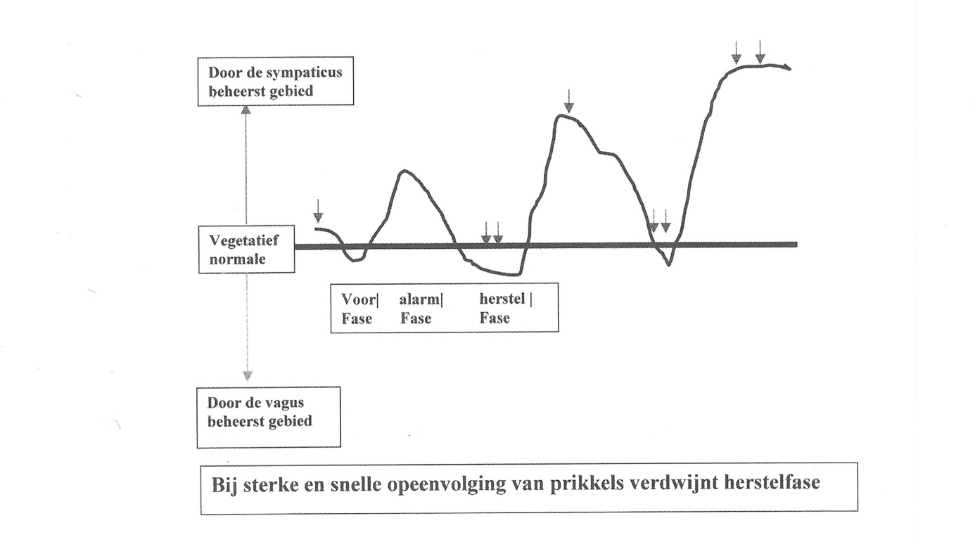
The preliminary phase is the growing tension for an acute explosion of tension. Think of the waiting for an exam result, the drumming with the fingers ‘silence before the storm’. The preliminary phase of this growing stress event, which may be long or short, is controlled by the particular part of the unconscious sympathetic nervous system what we call the para-sympathetic nerve or the vagus nerve and which first of all puts the blood circulation and metabolic processes in the ‘awaiting position’. After this decreasing of the vital functions, the acute alarm stage follows, the main stage of the stress response with a steep increase in activity where the sympathetic nervous system takes over. This is the active system of the unconscious nervous system that mobilizes all kinds of energies in the body such as the acceleration of the breathing, the increase of muscle tension, the increase of blood pressure and much more. Then, normally the stage of recovery follows after such an acute alarm stage. The ‘excitement’ of the sympathetic system decreases and the increased functions of the metabolism and the blood circulation return to their resting condition or even decrease further, again under the influence of the parasympatheticus to below the exit level (see diagram). In principle, this three-cycle is a very useful biological mechanism because it makes remarkably effective use of physical energies in order to overcome the stressors.

Neuro-endocrinal system HSAM = hypothalamus – sympathetic nerve – adrenal medulla – axis (Fight or flight). This is the response of the body to acute stress. This mechanism is led by the sympathetic nervous system and its chemical messengers: the catecholamines (epinephrine and norepinephrine). The sympathetic (unconscious) nervous system is controlled by the hypothalamus, a small but powerful part of the brain. As a response to stress, the adrenal medulla is stimulated to produce among others adrenaline. Extra blood is sent to the muscles, the blood pressure increases, and the blood glucose level increases. The liver increases, it stimulates the detoxification and protecting substances are secreted. Furthermore, the digestion is suppressed because this organism is not directly vital. Then a production of mood-enhancing and pain-killing substances takes place in the brain (enkephalines). All these responses together are called the ‘flight or fight responses’. This is the condition in which a person had to survive in an acute exposure of stress. In modern time it is often not only a physical stress trigger but also psychological stress which causes a person to react as if he were in mortal danger. If a person, however, has to deal with stress responses in his/her body for a long period of time, e.g. when he is reading the newspaper and his body reacts as if it were in mortal danger, then things go bad. (Exhaustion stage, see the above)
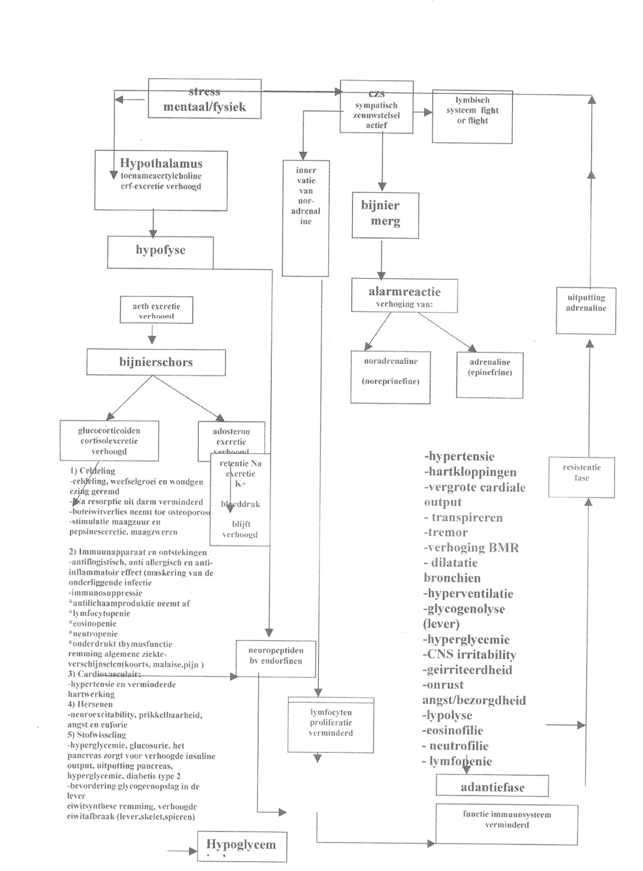
HHAC Hypothalamus – Hypophysis Adrenal Cortex -axis. Seleye described the release of cortisones (cortisol) under the influence of stress. This is after the acute response of the body which we call HHAC-axis. Negative results occur due to long term stress by constantly exceeding the strainablity of the body. In test animals it resulted in atrophy of the lymphatic tissue and thymus tissue (thyroid gland), hypertrophy of the adrenal cortex and bloody ulcers.
The hypophysis (brain gland) produces CRF (corticotrophin-releasing factor) which leads the brain gland to release ACTH (adrenocorticotropic hormone) in the blood. This causes the adrenal CORTEX to produce glucocorticoids. This tempers the stress responses by slowing down the inflammations and by moderating the immune system. This is a good thing, other wise man would die from the long term extreme responses to stress. (This is the HHAC-axis that constantly communicates to the HSAM-axis). The disadvantage is that due to the constant cortisol production, the harmful substances can cause an expanded connective tissue formation in tissues and organs (Fibromyalgia!) The cortisol has increased in the 1st stage of GAS. In the 2nd stage it is normal and in the 3rd stage it has increased again (exhaustion). Glucocorticoids thus moderate the stress responses and they slow down a too strong defense to the stress trigger. Therefore, many glucocorticoids in the blood indicate exhaustion. A strong (short term) strain makes the ACTH-level increase much less than many smaller strains. These strain factors can be physical stressors: heat, coldness, extreme muscle labor and damage or trauma of the tissues. But consider also psychological factors such as fear, manipulation, coercion (compare it with the results of the research on a rat in a straitjacket by Seleye). The ACTH with consequently the production of glucocorticoids, can also be improved under the influence of our thoughts. If we consider physical stress, strong emotions and loss of control, we see also a strong increase of ACTH and cortisol. Besides ACTH, which enzymatically is cut from the same pro-hormone, beta-endorphins are also produced, which provides a reduction of pain and makes it easy when exceeding the strainability. The glucocorticoids which are released during stress also have an effect on the memory. They make us remember a stressful event better (sensibilization). People often talk negatively about glucocorticoids from the adrenal cortex, but without them we cannot live. White blood cells clean up the damaged tissues by breaking down macro-molecules with enzymes. Glucocorticoids reduce the release of these enzymes, so that the sometimes aggressive inflammation reaction is tempered.

Homeostasis
This is how the homeostasis is maintained (biological balance). However, due to high glucose concentrations also the protein synthesis is reduced, which causes the liver to produce glucose from the amino-acids (glucogenesis). This can lead to the reduction of the quantity of proteins in the muscles, the ligaments and in the tendons, also the quality of the connective tissue decreases (due to the insufficient formation of matrix and collagens). In its turn, this causes a reduced strainability of the muscle tendon and the bone system. With stress, the healing of wounds is delayed by up to 40%, partly due to the suppression of the immune system. Also with psychological stress (mourning, etc.) the same numbers are found. Due to stress, the nervous system is wonderfully mobilized orthosympathetically, whereas it is physically hardly discharged. The modern man moves only 15% in comparison to two centuries ago and he deals with more stress in relationships, social interaction, work place and environment. The once mobilized fatty acids are gradually converted into cholesterol and are deposited on the vessel walls, which accelerates arteriosclerosis. A shift is taking place in the hormonal system due to stress and as a result abnormalities occur in the vegetative nervous system. Insecurity and nervousness do trigger the stomach to greater gastric acid deposition and bowel cramps (irritable bowels) via the hormonal system. The natural repulsive sexuality due to stress is being reduced, so that secondary stressors such as frustration lead to impotence. Merely because of the diminished immune system, chronic stress leads more easily to cancer, also due to the weakening of the thyroid that normally plays a major role in the resistance mechanisms.

Other chronic consequences
Other chronic consequences of stress are: fluctuating blood sugar levels, depression, sleeping disorders, and heart and blood vessel disorders. (See among others my book stress part 1 and my articles ‘The whole man’ part 1 and 2 (in Dutch).
The psychology of stress To map the different ways of dealing with stress, we can use an adapted stress model by Gaillard (1996). Hereby the correlations between mental/emotional burden and the strainability of men are mapped. We can expand it with spiritual factors. The first division of stress factors are factors that are within or outside man (environmental factors). It’s important to distinguish that the parts of the stress factors mentioned can differ in nature and in impact. The death of a husband or wife weighs heavier of course, than that of a boss that temporarily asks too much. Outside the objective extent of stress, it’s of course significant to see how a person experiences it him-/herself (subjective). With chronic stress complaints it has become apparent, as formerly mentioned, that chronic ‘small’ stressors have a more negative impact on the long term than one great acute stressor. Of course, man has to do with a sum total of different kinds of stressors. With regard to environmental factors, you can think of physical aspects such as noise pollution, vibration, temperature influences, physical and repetitive work without breaks, etc. Furthermore, you can list work environmental stressors like job tasks, shiftwork and dull irresponsible work. As third environmental factor, we can mention the role conflicts such as an unclear employment agreement, responsibilities, and an unlimited job description.
The most important negative stressors are often uncontrollable negative situations and on the other hand the incapability of (partially) letting go of matters (perfectionism).
As fourth environmental factor we have relational factors such as authoritative leadership, a bad work climate, bad family relationships and other social relationships at work and in the family, church and in leisure time.
The fifth point is career development as a source of stress (Sutherland 1988) or when there is a discrepancy between what one does and what one receives. (Money, promotion). The most important negative stressors are often uncontrollable negative situations and on the other hand the incapability of letting go (partially) of issues (perfectionism). Karasek demonstrates that the impact on work environment and well-being can be foretold by two factors: the workload and control space.

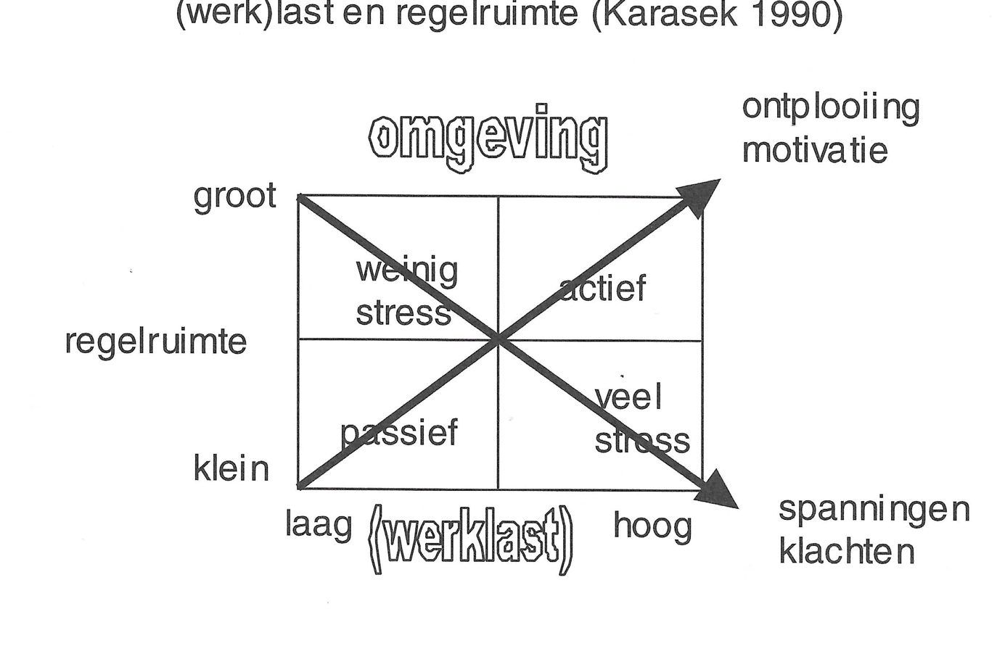
The latter includes the possibilities to solve problems, to make decisions, to postpone certain tasks for a while and to take one’s own responsibilities, which are clearly limited. Burken (2000) expands it with a third factor: social support (Johnson 1988).
Control space and controllability are closely related to one another. There where we can control matters actively, stress management becomes easier. So the environment may have high requirements (somebody has e.g. five children, but he has many control space: time, money, babysitters, spiritual life). In that sense there is a positive stimulating life environment that makes a person entrepreneurial. Owing to the large control space he/she can fully develop him-/herself. Passively, the requirements can be very low, e.g. no employment while the control space (no suitable education, no social network, no spiritual life) is limited. This situation can lead to apathy and depressive feelings. Because too little use is made of his/her abilities, they will gradually lose their skills and eventually become unable to use these skills at all.
When there is little stress: here, the requirements are low, combined with a large control space. For example middle-aged people with a good relationship and sufficient financial possibilities. Much stress: the environment requires high standards, e.g. four children, one of whom is disabled, and a co-habiting mother in law with Alzheimer disease, while the control space is limited, no support from family, no money for a babysitter etc.

Through what lens does one view stress?
A person will experience stress in a situation that is assessed as a threat, a loss or a challenge. Do these stressors involve complaint related factors such as pain, functional limitations, reduced social participation, or are there more stressors involved that have to do with the living environment, such as an overloaded day schedule? Furthermore, one can distinguish the primary assessment of a situation whereby one rapidly assesses whether it is a potential (physical) threat. Furthermore, the stress response depends on the secondary assessment, which is the refined effect of the situation: what do you think you can do? Nothing or anything at all? What do you estimate in terms of coping resources? Usually, coping is both focused on the problem and on the emotions as well. Due to heavy emotions, the problem-solving ability can be disrupted. In case of problem-oriented behavioral coping, one will gather information, make plans, consult with others, etc.
The (re)gaining of control over a problematic situation is in this case generally convenient, and therefore the threat is reduced. This form of coping, however, is inconvenient if the psycho-physiological costs are higher than the benefits. If the necessity of exercising control is difficult and takes a lot of mental or physical efforts, this form of coping on the contrary will lead to an increased sympathetic activity. (Dantzer 1993)
Problem-solving coping is also called active coping and is associated with the increase of activity in the adrenal cortex axis. In addition, there is a problem-oriented cognitive coping, which takes place when one looks differently at a problem. He will highlight and re-evaluate other aspects in a difficult situation. One can learn from problems. Of course a disaster remains a disaster. With emotion-oriented behavioral coping, one soothes the negative emotions. One will show tension distracting activities, such as nail biting, moving with the feet or teeth grinding. Some ‘hide their heads in the sand’, which by the way works better with acute stressors than more chronic ones. However, one can also seek social emotional support through information or via persons. Finally, there is this emotion-oriented cognitive coping that takes place when someone tells his/her story. This is beneficial when it goes together with the expression of the corresponding emotions. (Pennebaker 1988). It reduces the arousal because the telling of the story compels a cognitive process. There are also strategies that causes a greater distance to the problem, such as emotional inhibition, repression, defensive avoidance and denial. Generally, in case of problems that appear to be chronically unsolvable, more emotion-centered strategies should be applied, and in case of changeable problems, there should be more problem-solving strategies.
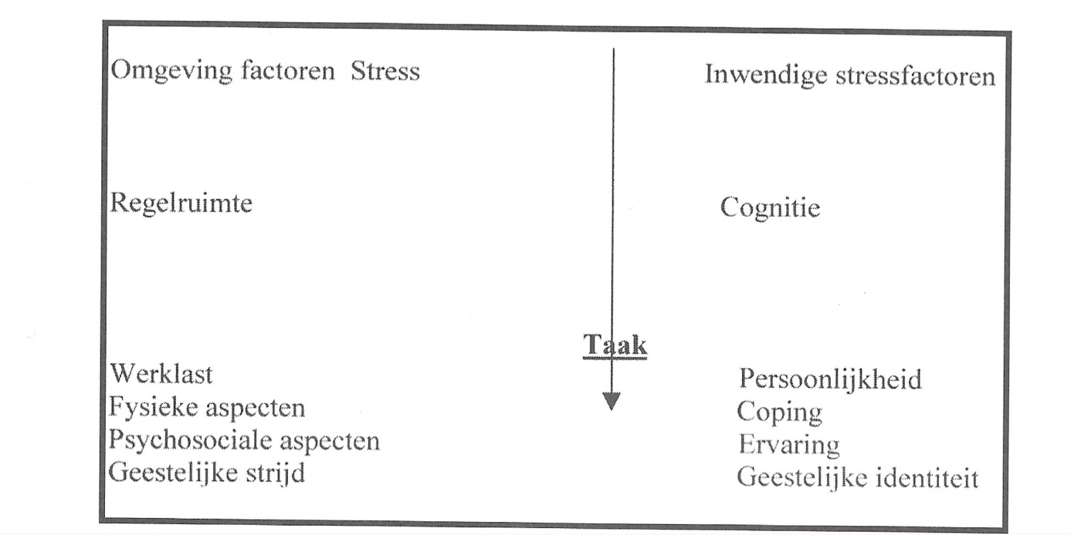
Differences in cognitive functioning can affect the stress process in different stages. (Payne 1991). An important component is the contextual intelligence. This intelligence is important for adaptation in daily life. It contains among others components, such as verbal abilities and social competence. Because of a strong problem solving ability or insight, the primary assessment is often better. The verbal and social abilities provide sufficient information (reading, organizing a meeting). A bad problem solver will not examine his coping resources carefully, (bad secondary assessment) and ask less for advice and support. They score low on communication, while that is precisely the core to bring about changes on the social level. (Payne 1991).

Stress and spiritual life
If we really want to find rest and peace, we should reject the make-believe rest that the world offers in all kinds of forms and sizes, and first and foremost go to Him Who alone can give rest and peace: Jesus Christ. It is Him, God Himself, who also became man, to Whom every man should go.
By His substitutionary suffering and death and through His resurrection, anyone can freely come near to God through faith by grace and receive rest that goes beyond any reason. Jesus Himself says it in Matthew 11. You who are weary from the burdens that are pressing on you, come to Me, I will give you rest.
Take My yoke upon you and be My disciple. For I am gentle and humble at heart. With Me you will find deep inward rest. My yoke is not heavy; the burden that you have to carry for Me is light.
We have already seen earlier that man is an unbreakable unity of body and soul. Therefore it is important to seek possibilities in this unity. Biblically, in this unity, our thinking takes a very important place.
Our thinking determines for the greater part our emotion, our behavior and our habits. By nature, we can only consider ourselves in our thinking. All of our thoughts, no matter how noble they may be wrapped, are in the end just selfish and self-centered. Our thinking is very limited because it is fed by limited information that is also colored.
Our thinking shall have to be changed. Our thinking shall have to be built up from steadfast unshakeable foundations that contain truth. This can only happen if our thinking is led by the only truth, i.e. the Spirit and the Word of God.
God calls upon us in His Word through the letter to the Romans to renew our natural thinking so that by being led by the Spirit of God we discover what the will of God is for our personal life. So it can happen that God’s Spirit will transform us increasingly clear through our thinking, our willing and our feelings.
In Romans 12: 1, the Living Word reads: “Therefore, I urge you, brothers and sisters, in view of God’s mercy, to offer your bodies as a living sacrifice, holy and pleasing to God—this is your true and proper worship”. God enjoys having you all to Himself. Only in this way you can serve God. You should not become as people who don’t care about God. No, you should become different by a new way of thinking. Then you will be able to understand what God’s will is. And what He wants is good, pleasant and perfect. Will a born-again Christian then be spared from all kinds of stress factors?
Certainly not. He will just learn in a different way to deal with them, i.e. in God’s way. He can use these things for the better and in this way also the personal faith is often purified because people learn in God’s way to cope with problems in God’s world. God makes many promises in the Bible from which a Christian who builds his/her life can find much comfort, strength and rest. So there is e.g. the promise of the security that nothing can separate us from the love of Christ. Even if we don’t feel or experience it always, it is an unshakeable certainty.
Christians can know in all difficult circumstances that God is present and eventually has everything in His hands. So God makes the promise in the Bible to His children, the Christians: “You can always trust Me, I will never put you to shame”. Whatever hardships and worries that Christians may have, they may e.g. also surely know that they will never be tempted beyond what they can bear. He will also provide a way out so that they can endure it. That is a wonderfully consoling thought that many Christians have cherished.

God is faithful
Another consoling thought in all circumstances is: There is hope. A Christian can have many difficult times in his life, but he has the perspective for a better, secure, eternal rest with God, without sorrow, fear and worries. How can an unbeliever who is facing death have security for eternity and life without God? Is that the only thing that makes a Christian life stress-resistant, a secure future and a secure expectation from the Bible? No, it doesn’t stop there. Every Christian can daily come near to God and bring everything to Him in prayer.
He needs to be transformed in his thinking, as we have already seen. Not only for the future but also today. Building his life, making decisions and choices in prayer and obedience to God. He can bring Biblical priorities into his life that increasingly gives him rest and dependence on God.
Listen to the voice of God. So, many things ought to be removed from our old life and new things must be learned. That is an active process whereby the believer can work with God’s help in all areas of our lives, our family, our work, our relationships, our money, and our capabilities. Just read Ephesians 4:20.
If you have really heard His voice and He has revealed the truth about Himself to you, then you ought to put off the old human nature as an old dirty garment. That’s your former way of life through which you suggested to find happiness and peace, but which only brought you death and corruption in reality. Your thinking needs to be renewed more and more profoundly. In fact, you need to become a whole new man that only lives for God, purely and good. Put on the new nature as a set of new clothes.
It is important to strengthen our will in doing so by faith in Christ in order to come to God’s solution for our problems. Also important is that God speaks and helps through the Holy Spirit, the Word, through other believers and through the church. We shall have to make priorities in our seeking and actions, even though it doesn’t always line up with the time that we formerly spent to these things.
Prayer, study, obedience and perseverance are some keywords of such a way in faith that leads to spiritual maturity in Christ. Surrender, humbleness, confession, remain standing, His words in the Bible that give substance to our stress-resistance. But certainly also joy, happiness, victory, are parts of the life with Christ. We shall limit ourselves to some tips that you can ponder in your relationship with Christ and which you can pray for to establish your life according to His will.

Tips
- If you have not yet accepted the Lord Jesus as your personal Savior … don’t hesitate any longer! Surrender your life to Him, Who has given His life for you. Who loves you with a Divine love. Believe in His accomplished work.
- Take time for fellowship with God by praying, listening, giving thanks, reading and singing. (Colossians 3:14-17)
- Seek cleansing of your heart and thoughts by confessing your personal sins, and by dedicating your life to Christ. (1 John 1:7)
- Seek fellowship with other believers within a local church.
- Search for the place and the gifts of grace that God has given you to serve Him. (1 Corinthians 12:7)
- Strengthen your will and faith in this local congregation. Search together with God for Biblical priorities and Biblical thinking about your relationships, relations at your work place, your family and hobbies. (Colossians 3:18-25)
- Know your own possibilities, don’t overestimate yourself; do not be proud. Acknowledge that you’re living in a world of stress and fight wisely.
- Also identify your physical limitations, such as fatigue and do something about it in a timely manner.
- Take wisely care of your body; it is the temple of the Holy Spirit. Stay physically fit; move wisely; go for a walk, or go for a bike ride or go swimming. Sleep sufficiently and on time, and don’t get involved with all kinds of false calming agents such as tranquillizers, drugs, alcohol and smoking.
- Accept and identify your physical feelings of stress; learn to deal with them Biblically. Learn to recognize the tension signals and to reduce the physical trigger level by doing muscle awareness exercises and breathing exercises.
- Also learn to know your body better and better by taking a better attitude and by movement patterns. Here too, exercise makes perfect and you will need to have patience and perseverance.
- Allow yourself to get physical rest. Also in buying furniture. Allow yourself to be well informed, also regarding your work situation, such as working height of your desk etc., etc. A good chair that gives good support, and is high enough in proportion, is gold. That’s where you can get a good physical rest.
- Look for hobbies and leisure time activities where you can also relax to the honor of God, and where you can meet other people and where you and others can be of service.
- Man is also a social creature. Also help others practically by rolling up your sleeves.
- bring order and regularity in all things. Certainly with regards to your daily repeated activities, such as eating, sleeping and working at regular fixed times. Your body has an awesome biological clock which functions optimally with order and regularity.
- Of course we realize that we have been able to offer only some things. We do hope that you have read that we have unprecedented opportunities to cope with stress.

Looking at problems from the relationship with Jesus
Are many psychological and physical management methods focused on gaining self-control and to have an overview in situations? Spiritually speaking, surrendering to God is a significant aid. Of course you should not play the psychological and spiritual principles against one another, they are both very important. There are a lot of principles of stress management in the Bible from which we can learn. The word in the Bible which is most similar to stress, we find in John 16:33 and it reads: “In this world you will have trouble. (thlipsis= pressure, affliction, distress) But take heart! I (Jesus) have overcome the world.” The world stands for cosmos, the spirit of this world time, everything that we come into contact with in this time. One of the main stress factors of a man is the fact that we live in two realities. The spiritual reality (SR) and the earthly reality (ER). We confess a lot in spiritual sense: We no longer live for ourselves, but for Christ (Gal.2:20); we walk in heaven with Christ; we are blameless and clean; spiritually blessed with all spiritual blessing in Christ (Eph.1) etc.
In daily life in the earthly reality, it is sometimes difficult to let the spiritual reality integrate. In the daily stress of work, relationships, imperfections, lack of money, sinful behavior, rejection, disappointments etc., we experience the pressure of the cosmos (world). Often, the field of tension between what we confess and what we do not do leads us to flee to only the spiritual reality or to only the earthly reality.
We become over-spiritual, we speak ‘the language of Canaan’ and walk alone with our head in the clouds without having any contact with our earthly responsibilities in our family, work place, city and society. This leads to a ‘stress schizophrenia’ that can make people sick. The other way of escape is that people throw their spiritual life and insight totally overboard and only focus on the earthly reality. Or, due to the field of tension, they feel so sinful that there seems to be no grace for them in faith. No, the best stress-management is to integrate the spiritual reality in the earthly reality. In the above cited text, Jesus says: “In this world you will have trouble. But take heart! I have overcome the world.” Beside a real awareness of our own responsibilities, we need to realize that the Biblical promises will remain standing, in spite of the visible appearance of the opposite. God will not allow us to be tempted beyond what we can bear; He is with us to the very end of the age; He’s got everything in His hand; He is in control in the world and in our life. We need to look at things from above, from another perspective, meaning: from the possibilities of God Himself. In psychology this looks like the problem-oriented cognitive coping, with the difference that here it is not only a perception of things but the objective truth. Another important stress technique is the emotion-oriented cognitive stress coping, which we also recognize in the Bible, when God calls us to pour out our hearts and bring our emotions to Him (Such as in Psalms 83 and 86).
Many are inclined to only focus on their problems in their lives (among others stress). They are being hypnotized by the problem as it were and in their awareness only videos with that problem are running repetitively. They are in danger of being overwhelmed and paralyzed by the problem.

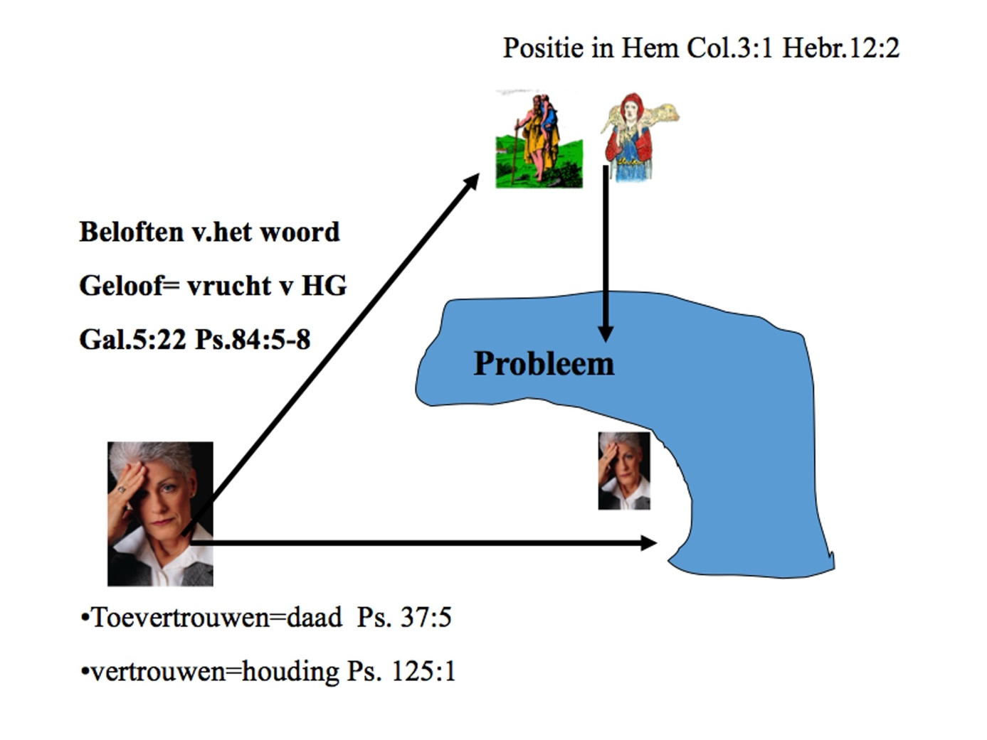The problem is then between them and God. God seems no longer approachable. The solution is looking at the problem ‘from above’ in the position of Christ, as High Priest, Shepherd and Father. Yes indeed, but you look at it from another position, with other possibilities (in Christ). That looks easy, but is not. You need trust to do that. Trust as a deed of your will, meaning commit your way to the Lord, radically (Psa. 37: 1-5). Such trust and confidence is also an attitude (Psa. 125). Trust (= faith) is based on the promises of the Word of God, by relying on it more and more and involve God in all aspects of your problem. (By integrating the earthly and spiritual reality) you learn to walk ‘the paved path of your heart’ more and more (Psa. 84: 6-8); then a fruit of the Holy Spirit arises as a result of such fellowship (communication).
In Romans 6: 5-14 it is written that we have been ‘planted together’ with Christ in the likeness of His death. In that coexistence (co-experience), if the way to God is constantly followed, a fruit grows, which is (faith) confidence/trust (Gal. 5:20 pistis). This is sometimes the higher purpose of God in a man’s life, not to keep him/her from all kinds of stress or to satisfy Christians in all of their (sometimes fleshly) desires and need, but to teach them to live by faith. (The righteous shall live by faith Rom. 1:17). That doesn’t mean that the Christian should passively wait until God has fixed everything, but that he/she, by this attitude of faith, receives power, insight and wisdom from God to deal with matters by the possibilities given by God. Sometimes it implies a renewed way of fighting from this new perspective. Sometimes it also implies that one gets the power to forgive others and him-/herself from the forgiveness of Christ; sometimes it implies that after the loss and mourning of a loved one, we receive hope and courage again for a future.
We have wonderful opportunities to become stress-resistant, just as Paul writes in the letter to the Philippians in chapter 4:11-13 ‘I am not saying this because I am in need, for I have learned to be content whatever the circumstances. I know what it is to be in need, and I know what it is to have plenty. I have learned the secret of being content in any and every situation, whether well fed or hungry, whether living in plenty or in want. I can do all this through him who gives me strength’. Verse 19 reads: ‘And my God will meet all your needs according to the riches of His glory in Christ Jesus’.

Literature:
- Frederic Vester: het verschijnsel stress (the stress phenomenon), sesam speciaal 1977 Bosch& Keunig isbn 9024669847 P.v Burken, J Swank: Gezondheidspsychologie voor de fysiotherapeut 2000, Bhn Stafleu van Loghum. Houtenisbn 90 313 0116
- Karasek R, Theorell Healthy work New York Wiley 1990 Petrie K Moss-Morris R Coping with chronic illness In : Baum A Newman S Cambridge handbook of psychology Cambridge press 1997:84-7 Gaillard AWK Stress, productiviteit en gezondheid Amsterdam Nieuwezijds 1996
- Payne R Individual differences in cognition and the stress process In Cooper C Payne R Personality and stress individual differences in the stress process. Chichester (Eng) John Wiley 1988: 669-80
- Gerard Feller, Promise Bijbels omgaan met spanningen / stress deel 1 uitgebreide druk Oudewater 2002
- Dr Kurt Blatter, Promise, Bijbels omgaan met stress deel 2, Oudewater 1999 isbn 90-74507034 James W Kalat : Biological psychology, stress and health, ISBN 0534514006 Belmont USA 2001
- Watson D, Pennebakker JW Health complaints stress and distress Exploring the central role of negative affectivity Psychological Review 1989, 96 234-54
- Feller GPM, artikelen in Promise heel de mens 1 en 2 (the whole man) in 2001
- Pennebakker JW Confiding traumatic experience and health In Fisher S Reason Handbook of life stress, cognition and health Chichester John Wiley 1988: 669-80
This article is translated from the Dutch article about Stress Manamegent. Therefore our apologies forthe DUtch language in the model-pictures. No part of this article may be reproduced, copied or used without the express permission of the foundation and the author/translator. Of course, according to the usual rules of source attribution, it may be referred to in other publications. If in doubt, please contact us first via the contact form.
Translation: Ursula Moestapa

